

**Timeshare Exchange Platform**

**Software Requirement Specification**

**Members:**

Võ Minh Đức - SE173255

Đào Xuân Tịnh - QE170214

Đoàn Dương Minh Trí - SE173111

Đỗ Huỳnh Nguyên Vũ - SE173139

– Ho Chi Minh, March 2024 –

**Table of contents**

**I. Overview** **3**

1. Introduction 3

a. Background 3

b. Business Opportunity 3

c. Vision Statement 4

**II. System Features** **4**

1. Use Case Diagram 4

Figure 2.1: Use Case Diagram 4

2. Use Case Specification 5

2.1 Guest 5

2.1.1 Search Timeshares 6

2.1.2 Register Account 9

2.2 Renter 14

2.2.3 Request to rent 14

2.2.4 View my rental request 18

2.2.5 View rental request details 21

2.2.6 Pay for rental request 23

2.2.7 Cancel the reservation 26

2.2.8 View Trip 29

2.2.9 Upgrade Account 32

2.2.10 Pay Fee Upgrade 35

2.2.11 Interact with Owner 38

2.2.12 Interact with staff 41

2.3 Registered User 45

2.3.13 Login 45

2.3.14 Log Out 48

2.3.15 View Profile 51

2.3.16 Edit Profile 54

2.4 Owner 59

2.4.17 Upload new timeshare 59

2.4.18 View my timeshares 65

2.4.19 Update a timeshare 68

2.4.20 Delete a timeshare 73

2.4.21 Upgrade Owner Account Service 76

2.4.22 Owner Interact with Renters 79

2.4.23 View timeshare details 82

2.4.24 Accept the timeshare exchange request 84

2.4.25 Request to exchange 90

2.4.26 Accept for renting 94

2.4 Admin 98

2.4.27 Support User 98

2.4.28 Update service packs 102

2.4.29 View All Transactions 106

2.4.30 Create trip 109

2.4.31 Verify timeshare 112

2.4.32 Authorize Account 115

2.4.33 Filter Account 120

2.4.34 Manage Configuration 124

2.4.35 View account detail 127

View account detail 128

2.4.36 View account list 132

2.4.37 Ban account 135

3. System Functions 141

a. Screen Flow 141

b. Screen Details 141

c. User Authorization 142

4. Entity Relationship Diagram 143

5. Sequence diagram 144

a. Register 145

b. Post a timeshare 145

c. Request a timeshare rental 146

d. Accept a timeshare rental 146

# **I. Overview**

## **1. Introduction**

### **Background**

Everyone takes time to find a vacation for themselves during major holidays of the year. They spend time on social networks or websites to find places to travel but it takes too much time because their choice has been booked by many others. In addition, an individual who owns a timeshare with desired vacations can rent or exchange vacations in many other places in the country or around the world by saving on accommodation costs.

### **Business Opportunity**

The timeshare travel industry has seen significant growth, with many individuals looking for platforms to efficiently book and exchange their timeshare properties. fruit. NiceTrip, an innovative timeshare booking and exchange platform, addresses this need by offering a series of special features that differentiate it from existing platforms.

* User-centered interface design: Our platform prioritizes a user-friendly interface, streamlining the process of booking and exchanging timeshare properties. This emphasis on usability allows users to manage their timeshares.
* Seamless booking and exchange: NiceTrip allows users to search, book, exchange, and manage their timeshare properties seamlessly. By integrating booking and exchange functions, we provide a comprehensive solution for owners and owners of timeshares.
* Robust moderation and governance: NiceTrip implements robust moderation and governance features to ensure a safe and respectful online environment for all users.

In short, NiceTrip goes beyond traditional booking platforms by providing a comprehensive ecosystem designed to facilitate the booking of timeshares. Through user-centered design, global reach, and customer focus, NiceTrip aims to help timeshare owners register, exchange, and maximize the value of their assets.

### **Vision Statement**

For users who want easy access to convenient vacations nationwide, the Timeshare Exchange Platform is a website that allows them to search for vacations and exchange them easily and conveniently. Unlike having to go in person to book an exchange, users can contact timeshare owners more easily on the Timeshare Exchange Platform, which will help them save time and help them on their vacation easier.

## 

# **II. System Features**

## 1. Use Case Diagram

### **Figure 1.1: Use Case Diagram**

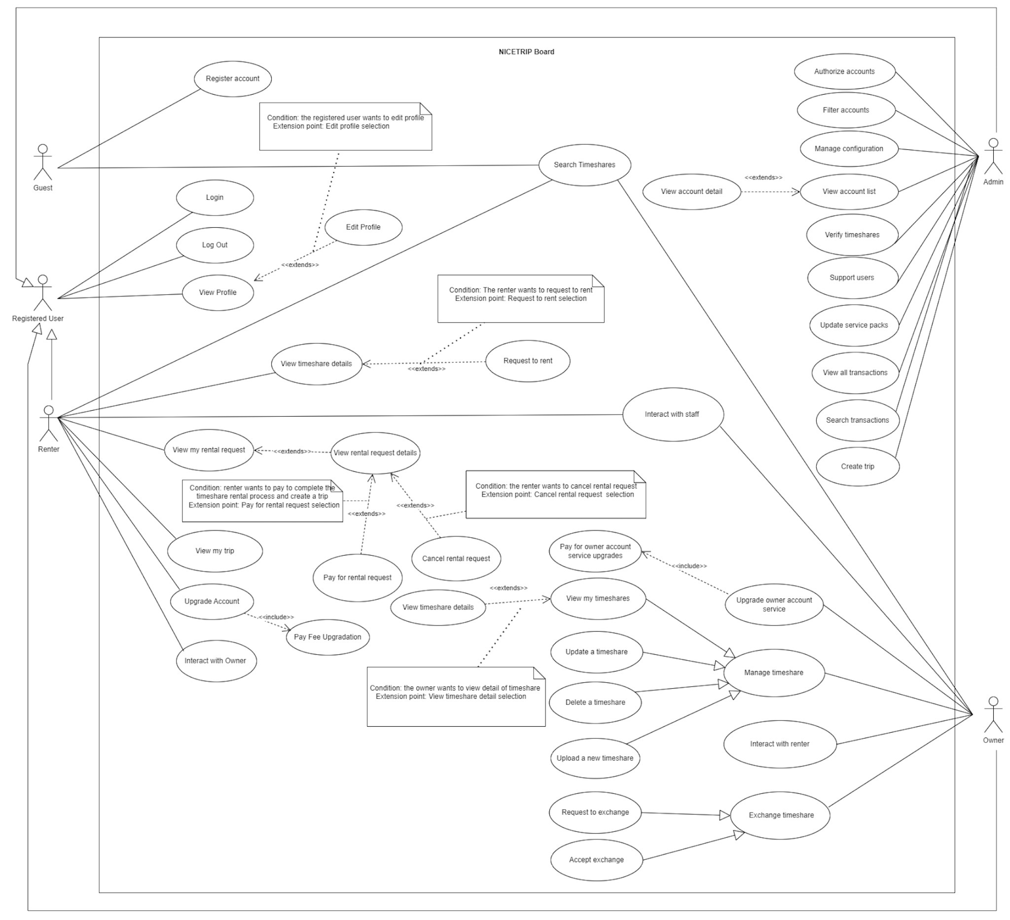

## 2. Use Case Specification

### **2.1 Guest**

#### **2.1.1 Search Timeshares**

| **USE CASE-1 SPECIFICATION** | | | |
| --- | --- | --- | --- |
| Use-case No. | UC01 | Use-case Version | 1.0 |
| Use-case Name | Search Timeshares | | |
| Author | Đào Xuân Tịnh | | |
| Date | 23/02/2024 | Priority | High |
| **Actor:**  Guest, Renter, Owner.  **Summary:**        The user wants to search the owner's timeshares.  **Goal:**        The goal of this use case is to allow users to search the timeshare posts of the owners.  **Triggers:**          The guest and renter indicate that he wants to search posts when accessing the system's home page.  **Preconditions:**  **PRE-1.** The guest has accessed the system's home page.  **Post Conditions:**  **POST-1.** The system displays timeshare posts on the home page.  **Main Success Scenario:**   | **Step.** | **Actor Action** | **System Response** | | --- | --- | --- | | 1 | The actor accesses the system's home page via the link. | The system displays a list of owner timeshares. Each timeshare displays the following information:  {    - Phone number: phone number is a text with a length of 9-11.             - Account: is a text longer than 6 characters             - Password: Must be anonymous text and contain special characters, uppercase letters and numbers             - Re-enter password: Must enter the correct password.             - Check box to agree to the terms  } | | 2 | Guest fills in information about the timeshare they want to search into the form and presses the “Search” button | The system reloads the website and displays all timeshares containing the keyword the user entered. |   **Alternative Scenario:**   | **Step.** | **Actor Action** | **System Response** | | --- | --- | --- | | 1 | Renter logs into the system. | The system redirects to the renter's home page. | | 2 | Renter fills in information about the timeshare they want to search into the form and presses the “Search” button | The system reloads the website and displays all post time shares containing the keyword the user entered. |     **Exceptions:**         None.  **Relationships:**         UC-13: Login  (The actor must login before do this use case).  **Business Rules:**     BR-01: - Businesses require users to log in to take steps to view, add to cart and pay for timeshare. | | | |

#### **2.1.2 Register Account**

| **USE CASE-2 SPECIFICATION** | | | |
| --- | --- | --- | --- |
| Use-case No. | UC02 | Use-case Version | 1.0 |
| Use-case Name | Register | | |
| Author | Võ Minh Đức | | |
| Date | 23/02/2024 | Priority | High |
| **Actor:**  Guest  **Summary:**        Users register a new account on the system.  **Goal:**        The goal of this Use Case is to allow guests to register an account.  Triggers          The actor wants to register an account in the NiceTrip web application.  **Preconditions:**  **PRE-1.** User has not logged in  Post Conditions:  **POST-1.** <**Success>** The system stores user registration information.  **POST-2.** User is redirected to the Home screen   | **Step** | **Actor Action** | **System Response** | | --- | --- | --- | | 1 | On the registration page, the actor selects the "Register for member account" tab. | The system will provide a form to fill out with the following fields:             - Phone number: phone number is a text with a length of 9-11.             - Account: is a text longer than 6 characters             - Password: Must be anonymous text and contain special characters, uppercase letters and numbers             - Re-enter password: Must enter the correct password.             - Check box to agree to the terms  **[Exception 1]** | | 2 | Actor enters phone number, account, password, re-enters password, ticks OK |  | | 3 | Actor clicks on the "Register” button. | The system sends OTP via phone number and displays a form to fill in the OTP code. On the page there are two buttons “Send” and “Resend”  the OTP code.  **[Exception 2]** | | 4 | Actor input the OTP number and tick “Send”. | The system switches to the login page. |   **Alternative Scenario:**     | **Step** | **Actor Action** | **System Response** | | --- | --- | --- | | 1 | On the registration page, the actor selects the "Register a business account" tab. | The system will provide a form to fill out with the following fields:             - Phone number: phone number is a text with a length of 9-11.             - Account: is a text longer than 6 characters             - Password: Must be anonymous text and contain special characters, uppercase letters and numbers             - Re-enter password: Must enter the correct password.             - Check box to agree to the terms  **[Exception 1]** | | 2 | Actor enters Phone Number, Account, Password, re-enters password, ticks OK |  | | 3 | Actor clicks on the "Register” button. | The system sends OTP via phone number and displays a form to fill in the OTP code. On the page there are two buttons “Send” and “Resend”  the OTP code.  **[Exception 2]** | | 4 | Actor input the OTP number and tick “Send”. | The system switches to the login page. |   **Exceptions:**   | **No.** | **Cause** | **System Response** | | --- | --- | --- | | 1 | The password does not have uppercase letters or is missing characters | The information filled in the form is not correct  - If the error comes from the password, a red text appears below the form "Password lacks capital letters, is not long enough, lacks special characters".  - If the error comes from the phone number, the red text "Your phone number must only be 9-11 digits" will appear. | | 2 | OTP has expired. | - If OTP is not filled in for more than 1 minute, after entering the OTP code, the system will return "OTP has expired". |   **Relationships:**             None.  **Business Rules:**      None. | | | |

### **2.2 Renter**

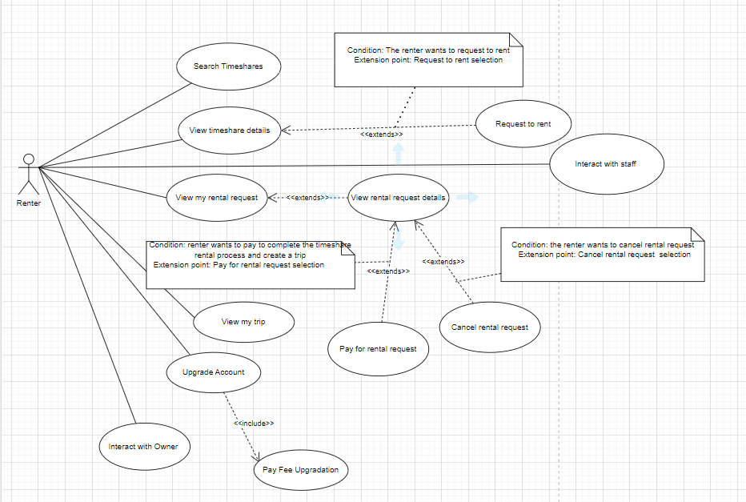

#### **2.2.3 Request to rent**

| **USE CASE-3 SPECIFICATION** | | | |
| --- | --- | --- | --- |
| **Use-case No.** | UC03 | **Use-case Version** | 1.0 |
| **Use-case Name** | Request to rent | | |
| **Author** | Đoàn Dương Minh Trí | | |
| **Date** | 23/02/2024 | **Priority** | High |
| **Actor:**  Renter  **Summary:**  The renter requests to rent a timeshare.  **Goal:**              This feature allows the renter requests to rent a timeshare.  **Triggers**          The renter indicates that they wanted to rent timeshare.  **Preconditions:**         1. The renter is logged into the system.  2. The renter has viewed the details of the timeshare.  **Post Conditions:**   • Success: The system displays a popup dialog "Request successful" and the rental request is recorded in the system.  **Main Success Scenario:**   | **Step** | **Actor Action** | **System Response** | | --- | --- | --- | | 1 | Renters log in to the system. | The system redirects to the home page. | | 2 | Renters click to timeshare cards.  [Alternative 1] | The system displays detailed information of the selected timeshare, including:  - Name of the timeshare.  - Id of the timeshare.  - Owner's name.  - Unit.  - Check in time.  - Check out time.  - Price.  - Total amount. | | 3 | Renters click the “Rent Now” button. | The system prompts the tenant to confirm personal information and agree to the rental terms, including:  - Country.  - Street.  - City.  - Province.  - Zip code. | | 4 | Renters click the “Send Request” button. | The system displays a popup dialog "Request successful" and the rental request is recorded in the system. |   **Alternative Scenario:**     | **No.** | **Actor Action** | **System Response** | | --- | --- | --- | | 1 | Renters click on timeshare cards from the timeshare list. | The system displays detailed information about the selected timeshare, including:  - Name of the timeshare.  - Code of the post.  - Owner's name.  - Unit.  - Exchange time.  - Check in time.  - Check out time.  - Price per night.  - Total price. |   **Exceptions:**   | **No.** | **Cause** | **System Response** | | --- | --- | --- | | 1 | Invalid input. | System informs a specified error message in a popup dialog. |   **Relationships:**            UC-15- Login  **Business Rules:**      N/A | | | |

#### **2.2.4 View my rental request**

| **USE CASE-4 SPECIFICATION** | | | |
| --- | --- | --- | --- |
| **Use-case No.** | UC04 | **Use-case Version** | 1.0 |
| **Use-case Name** | View my rental request | | |
| **Author** | Đỗ Huỳnh Nguyên Vũ | | |
| **Date** | 24/02/2024 | **Priority** | High |
| **Actor:**  Renter  **Summary:**        Renters view their list of rental requests.  **Goal:**              This feature allows renters to view their list of rental requests.  **Triggers**          The renter indicates that they want to view their list of rental requests.  **Preconditions:**  **PRE-1.** The renter has logged into the system.  **Post Conditions:**  **• Success:** The system displays the list of rental requests made by the Renter.  **Main Success Scenario:**   | **Step** | **Actor Action** | **System Response** | | --- | --- | --- | | 1 | Renters log in to the system. | The system redirects to the home page. | | 2 | The Renter selects the 'View My Rental Requests' button on the dashboard. | The system displays the list of rental requests |   **Alternative Scenario:**  N/A  **Exceptions:**   | **No.** | **Cause** | **System Response** | | --- | --- | --- | | 1 | No rental request found for the Renter. | The system displays a message to the Tenant as "There are no rental requests yet". |   **Relationships:**             UC-13 - Login  **Business Rules:**      N/A | | | |

#### **2.2.5 View rental request details**

| **USE CASE-5 SPECIFICATION** | | | |
| --- | --- | --- | --- |
| **Use-case No.** | UC05 | **Use-case Version** | 1.0 |
| **Use-case Name** | View rental request details | | |
| **Author** | Đào Xuân Tịnh | | |
| **Date** | 24/02/2024 | **Priority** | High |
| **Actor:**  Renter.  **Summary:**             The renter view rental request details.  **Goal:**        This feature allows renters to view rental request details.  **Triggers**          The renter indicates that they want to view rental request details.  **Preconditions:**         1. The renter has logged into the system.              2. Have at least 1 rental request.  **Post Conditions:**               Success: The system displays detailed information of the rental request.  **Main Success Scenario:**   | **Step** | **Cause** | **System Response** | | --- | --- | --- | | 1 | Renters log in to the system. | The system redirects to the home page. | | 2 | The renter selects the “View my rental requests” button on the dashboard. | The system displays the list of rental requests | | 3 | The Renter clicks on the rental request card. | The system displays the details of the selected rental request, including renter information and timeshare details. |   **Alternative Scenario:**             N/A  **Exceptions:**  N/A  **Relationships:**             UC-05 - View my rental request             UC-13 - Login  **Business Rules:**  N/A | | | |

#### **2.2.6 Pay for rental request**

| **USE CASE-6 SPECIFICATION** | | | |
| --- | --- | --- | --- |
| **Use-case No.** | UC06 | **Use-case Version** | 1.0 |
| **Use-case Name** | Pay for rental request | | |
| **Author** | Võ Minh Đức | | |
| **Date** | 24/02/2024 | **Priority** | High |
| **Actor:**  Renter  **Summary:**        Renters can pay for rental requests.  **Goal:**        This feature allows renters to pay for rental requests to complete a timeshare rental.  **Triggers:**          The renters indicate that they want to to pay for rental requests to complete a timeshare rental.  **Preconditions:**         1. The renter has logged into the system.              2. Have at least 1 rental request.              3. The rental request status is accepted.  **Post Conditions:**   | • Success: The system shows the message: Payment success”. | | --- |   **Main Success Scenario:**   | **Step** | **Actor Action** | **System Response** | | --- | --- | --- | | 1 | Renters log in to the system. | The system redirects to the home page. | | 2 | The renter selects the 'My rental requests' button on the dashboard. | The system displays the list of rental requests | | 3 | The renter clicks on the rental request card | The system displays the details of the selected rental request, including renter information and timeshare details. | | 4. | The renter presses the “Payment” button. | The system displays available payment methods including Paypal, VNPAY. | | 5. | The renter makes the payment | The system displays a successful payment notification and the system updates the booking's payment status as "Paid" and sends a request to staff for creating a trip . |   **Alternative Scenario:**  N/A  **Exceptions:**   | **No.** | **Cause** | **System Response** | | --- | --- | --- | | 1 | Technical errors during payment processing, system or database errors. | The system displays a general error message to the Renter and asks them to try again after a period of time or contact technical support. | | 2 | Loss of network connection or system error while the Renter is making payment. | The system displays an error message to Renters and asks them to check their network connection or try again after a period of time. |   **Relationships:**            UC-06 - View rental request details.            UC-13 - Login  **Business Rules:**  N/A | | | |

#### **2.2.7 Cancel the reservation**

| **USE CASE-7 SPECIFICATION** | | | |
| --- | --- | --- | --- |
| **Use-case No.** | UC07 | **Use-case Version** | 1.0 |
| **Use-case Name** | Cancel rental request | | |
| **Author** | Đoàn Dương Minh Trí | | |
| **Date** | 24/02/2024 | **Priority** | High |
| **Actor:**  Renter  **Summary:**        Renters cancel rental requests.  **Goal:**        This feature allows Renters to cancel rental requests.  **Triggers**          The renter indicates that they want to cancel rental requests.  **Preconditions:**         1. The renter has logged into the system.              2. Have at least 1 reservation.              3. Must be within the time period before the timeshare's check-in time.  **Post Conditions:**   | **Success**: Show a successful message in the pop-up. | | --- |   **Main Success Scenario:**   | **Step** | **Actor Action** | **System Response** | | --- | --- | --- | | 1 | Renters log in to the system. | The system redirects to the home page. | | 2 | The Renter selects the 'View My Rental Requests' button on the dashboard. | The system displays the list of rental requests | | 3 | The Renter clicks the “Cancel Rental Request”button. | Show a successful message in the pop-up. |   **Alternative Scenario:** N/A  **Exceptions**:   | **No.** | **Cause** | **System Response** | | --- | --- | --- | | 1 | The reservation cannot be canceled as the cancellation period has passed. | Show a failed message in the pop-up. |   **Relationships:**   UC-05- View rental request details  UC-13- Login  **Business Rules:**  N/A | | | |

#### **2.2.8 View Trip**

| **USE CASE-8 SPECIFICATION** | | | |
| --- | --- | --- | --- |
| **Use-case No.** | UC08 | **Use-case Version** | 1.0 |
| **Use-case Name** | View trip | | |
| **Author** | Đỗ Huỳnh Nguyên Vũ | | |
| **Date** | 24/02/2024 | **Priority** | High |
| **Actor:**  Renter  **Summary:**        Renters view information of the trip.  **Goal:**             This feature allows renters to view information of the trip.  **Triggers**             The renter indicates that they want information about the trip.  **Preconditions:**              1. The renter has logged into the system.              2. Have at least 1 trip.      **Post Conditions:**   • Success: The system displays existing trips.  **Main Success Scenario:**   | **Step** | **Actor Action** | **System Response** | | --- | --- | --- | | 1 | Renters log in to the system. | The system redirects to the home page. | | 2 | The Renter presses the “My Trip” button on the dashboard. | The system displays information of the trip, include:  - Id of the trip.  - Country.  - Check in time.  - Check out time.  - Total price. |   **Alternative Scenario:**  N/A  **Exceptions:**   | **No.** | **Cause** | **System Response** | | --- | --- | --- | | 1. | The system did not find any trips | Show the message "No trips available" in the trip view page. |   **Relationships:**  UC-13 - Login  **Business Rules:**  N/A | | | |

#### **2.2.9 Upgrade Account**

| **USE CASE-09 SPECIFICATION** | | | |
| --- | --- | --- | --- |
| **Use-case No.** | UC09 | **Use-case Version** | 1.0 |
| **Use-case Name** | Upgrade Account | | |
| **Author** | Đào Xuân Tịnh | | |
| **Date** | 24/02/2024 | **Priority** | High |
| **Actor:**  Renter  **Summary:**        Renters upgrade their account.  **Goal:**             This feature allows renters to upgrade their account.  **Triggers**             The renter indicates that they want to upgrade their account.  **Preconditions:**              1. The renter has logged into the system.     **Post Conditions:**  • Success: The system displays a successful account upgrade and updates the renter's role to the owner.  **Main Success Scenario:**   | **Step** | **Actor Action** | **System Response** | | --- | --- | --- | | 1 | Renters log in to the system. | The system redirects to the home page. | | 2 | The renter presses the “Upgrade Account” button on the dashboard. | The system displays available payment methods including Paypal, VNPAY. | | 3. | The renter makes the payment | The system displays a popup dialog "Request successful" and updates the renter's role to the owner in the database |   **Alternative Scenario:**  N/A  **Exceptions:**   | **No.** | **Cause** | **System Response** | | --- | --- | --- | | 1. | Renter payment failed | Show the message "Upgrade account failed" on the popup. |   **Relationships:**  UC-13: - Login  UC-11: - Pay fee upgrade  **Business Rules:**  N/A | | | |

#### **2.2.10 Pay Fee Upgrade**

| **USE CASE-10 SPECIFICATION** | | | |
| --- | --- | --- | --- |
| **Use-case No.** | UC10 | **Use-case Version** | 1.0 |
| **Use-case Name** | Pay fee upgradation | | |
| **Author** | Võ Minh Đức | | |
| **Date** | 24/02/2024 | **Priority** | High |
| **Actor:**  Renter  **Summary:**        Renters pay a fee to upgrade their account  **Goal:**             This feature allows renters to  pay a fee to upgrade their account  **Triggers:**             The renter indicates that they want to pay a fee to upgrade their account  **Preconditions:**             PRE-1: The renter has logged into the system.     **Post Conditions:**   • Success: The system notifies you of successful payment  **Main Success Scenario:**   | **Step** | **Actor Action** | **System Response** | | --- | --- | --- | | 1 | Renters log in to the system. | The system redirects to the home page. | | 2 | The renter presses the “upgrade ” button on the dashboard. | The system displays the payment method using an e-wallet. | | 3 | The renter makes the payment | The system displays successful payment |   **Alternative Scenario:** N/A  **Exceptions:**   | **No.** | **Cause** | **System Response** | | --- | --- | --- | | 1 | Technical errors during payment processing, system or database errors. | The system displays a general error message to the renter and asks them to try again after a period of time or contact technical support. | | 2 | Loss of network connection or system error while the Renter is making payment. | The system displays an error message to renters and asks them to check their network connection or try again after a period of time. |   **Relationships:**  UC-13: - Login  **Business Rules:**  N/A | | | |

#### **2.2.11 Interact with Owner**

| **USE CASE-11 SPECIFICATION** | | | |
| --- | --- | --- | --- |
| **Use-case No.** | UC11 | **Use-case Version** | 1.0 |
| **Use-case Name** | Interact with owner | | |
| **Author** | Đoàn Dương Minh Trí | | |
| **Date** | 24/02/2024 | **Priority** | Normal |
| **Actor:**  Renter  **Summary:**        Renters can interact with owner using the system's own chat system  **Goal:**             This feature allows Renters to directly ask and answer problems encountered with the owner through the chat system.  **Triggers**            Renters want to have the ability to interact directly with the owner to ask and answer things they want to know.  **Preconditions:**              1. The renter has logged into the system.   **Post Conditions:**   • Success: renters can communicate with the owner via chat box.  **Main Success Scenario:**   | **Step** | **Actor Action** | **System Response** | | --- | --- | --- | | 1 | Renters log in to the system. | The system redirects to the home page. On the bottom right corner of the screen there is an icon "Phone support person" and the words "Support questions and answers above the icon". | | 2 | Renters click on the icon. | The system displays a small chat frame below. The chat box automatically appears "Hello, what do you need help with?". | | 3 | The renter enters the question message into the chat form and press Enter. | The system sends a message to the staff and displays a waiting notification line for a moment.  [Exception 1] |   **Alternative Scenario:**  N/A  **Exceptions:**   | **No.** | **Cause** | **System Response** | | --- | --- | --- | | 1 | Unable to send messages because the network connection is too weak. | Display the message "Message has not been sent" in the chat frame, which is dimmer than the actual message. |   **Relationships:**   UC-13: Login  **Business Rules:**     N/A. | | | |

#### **2.2.12 Interact with staff**

| **USE CASE-12 SPECIFICATION** | | | |
| --- | --- | --- | --- |
| **Use-case No.** | UC12 | **Use-case Version** | 1.0 |
| **Use-case Name** | Interact with staff | | |
| **Author** | Đỗ Huỳnh Nguyên Vũ | | |
| **Date** | 24/02/2024 | **Priority** | Normal |
| **Actor:**  Renter, Owner  **Summary:**        Renters can interact with staff using the system's own chat system  **Goal:**             This feature allows renters to directly ask and answer problems encountered with staff through the chat system.  **Triggers**             Renters and Owners want to have the ability to interact directly with the system to ask and answer things they want to know.  **Preconditions:**              1. The Renter has logged into the system.   **Post Conditions:**  • Success: Renters and Owners can communicate with the staff via chat box.  **Main Success Scenario:**   | **Step** | **Actor Action** | **System Response** | | --- | --- | --- | | 1 | Renters log in to the system. | The system redirects to the home page. On the bottom right corner of the screen there is an icon "Phone support person" and the words "Support questions and answers above the icon". | | 2 | Renters click on the icon. | The system displays a small chat frame below. The chat box automatically appears "Hello, what do you need help with?". | | 3 | The renter enters the question message into the chat form and presses the “Enter” button. | The system sends a message to the staff and displays a waiting notification line for a moment.  [Exception 1] |   **Alternative Scenario:**   | Step | Actor Action | System Response | | --- | --- | --- | | 1 | Owner logs in to the system. | The system redirects to the home page. On the bottom right corner of the screen there is an icon "Phone support person" and the words "Support questions and answers above the icon". | | 2 | Owner clicks on the icon. | The system displays a small chat frame below. The chat box automatically appears "Hello, what do you need help with?". | | 3 | The Owner enters the question message into the chat form and presses the “Enter” button. | The system sends a message to the staff and displays a waiting notification line for a moment.  [Exception - 1] |   **Exceptions:**   | **No.** | **Cause** | **System Response** | | --- | --- | --- | | 1 | Unable to send messages because the network connection is too weak. | Display the message "Message has not been sent" in the chat frame, which is dimmer than the actual message. |   **Relationships:**   UC-13: Login  **Business Rules:**     N/A. | | | |

### **2.3 Registered User**

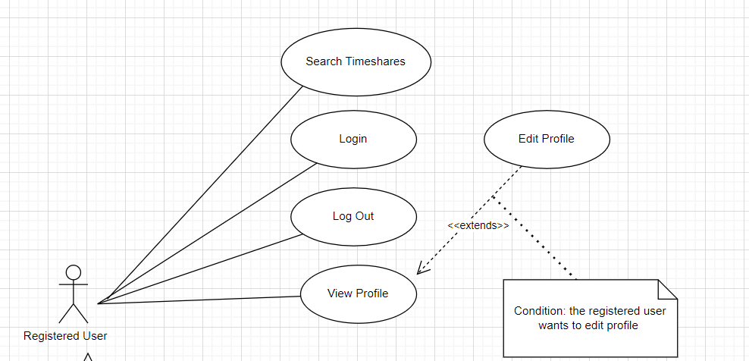

#### **2.3.13 Login**

| **USE CASE-13 SPECIFICATION** | | | |
| --- | --- | --- | --- |
| **Use-case No.** | UC13 | **Use-case Version** | 1.0 |
| **Use-case Name** | Login | | |
| **Author** | Đỗ Huỳnh Nguyên Vũ | | |
| **Date** | 23/02/2024 | **Priority** | High |
| **Actor:**  Registered user  **Summary:**        This use case describes the process of logging in users to the system using system account.  **Goal:**        This feature allows actor to login to website  **Triggers:**          The actor wants to authorize to the system so that he could access more functions as a member  **Preconditions:**  Actor has created an account in the NiceTrip application.  **Post Conditions:**  Success: System redirects actor to dashboard home page  **Main Success Scenario:**   | **Step.** | **Actor Action** | **System Response** | | --- | --- | --- | | 1 | In the login page, the actor inputs username and password and clicks “Login”.  **[Alternative 1]** | System validates username and password. If correct, redirect to dashboard home page.  **[Exception 1, 2, 3]** | | 2 |  | If correct, redirect to dashboard home page. |   **Alternative Scenario:**  **Alternative 1**   | **Step.** | **Actor Action** | **System Response** | | --- | --- | --- | | 1 | In login page, actor  select tab “Login with Google”. | System redirects to Google OAuth page | | 2 | User chooses Google  account and login | System validates email address. If correct, redirect to dashboard home page. |   **Exceptions:**   | **Step.** | **Actor Action** | **System Response** | | --- | --- | --- | | 1 | At least one input field doesn’t match the constraint | System shows an error message corresponding to the fail constraint. | | 2 | Username does not exist in the system | System shows error message: “Username not exist in the system” | | 3 | Password does not correct | System shows error message: “Password is not valid. Please enter again” |   **Relationships:**  This use case is related to the "Register User" use case.  **Business Rules:**  Users must have a valid Account to log in.  If actors input the wrong password 5 times, their username will be locked in 10 minutes. | | | |

#### **2.3.14 Log Out**

| **USE CASE-14 SPECIFICATION** | | | |
| --- | --- | --- | --- |
| **Use-case No.** | UC14 | **Use-case Version** | 1.0 |
| **Use-case Name** | Log Out | | |
| **Author** | Do Huynh Nguyen Vu | | |
| **Date** | 23/02/2024 | **Priority** | High |
| **Actor:**  Registered user  **Summary:**        The use case describes the process of logging out for renters, members, and admins.  **Goal:**        The goal of this use case is to allow users (renters, members, and admins) to securely log out of the system.  **Trigger**          The actor wants to sign out current account so that he can switch to another account or become guest  **Preconditions:**              User has authorized as a candidate or enterprise  **Post Conditions:**  Success: System redirects actor to login page  **Main Success Scenario:**   | **Step** | **Actor Action** | **System Response** | | --- | --- | --- | | 1 | In dashboard home page, actor clicks to “Log out”  **[Alternative 1]** | Call browser API to clear the local storage in the client and sign out the OAuth.  **[Exception 1]** | | 2 |  | Redirect the actor to the login page. |   **Alternative Scenario:**   | **No.** | **Actor Action** | **System Response** | | --- | --- | --- | | 1 | Actor click to avatar to open quick select dropdown | System generates an error message, notifying the user of the issue, and suggests retrying or contacting support. | | 2 | Actor clicks to “Log out” | Call browser API to clear the local storage in the client and sign out the OAuth.  **[Exception 1]** |   **Exceptions:**   | **No.** | **Actor Action** | **System Response** | | --- | --- | --- | | 1 | OAuth sign out error | System informs “Error! Please try again later”. |   **Relationships:**            This use case is related to other use cases involving user authentication (e.g., login).  **Business Rules:**  In addition to the JWT token information, other information related to the user must be deleted from the client when logging out. | | | |
|  | | | |

#### **2.3.15 View Profile**

| **USE CASE-15 SPECIFICATION** | | | |
| --- | --- | --- | --- |
| **Use-case No.** | UC15 | **Use-case Version** | 1.0 |
| **Use-case Name** | View Profile | | |
| **Author** | Do Huynh Nguyen Vu | | |
| **Date** | 23/02/2024 | **Priority** | Normal |
| **Actor:**  Register User  **Summary:**        This use case describes the process of viewing a user's profile within the system.  **Goal:**        The goal of this use case is to allow renters, members, and admins to view the profile information of a registered user.  **Triggers:**          The need for users to access profile information within the system.  **Preconditions:**  The user whose profile is to be viewed must be registered in the system.  The viewer must have appropriate permissions to view user profiles.  **Post Conditions:**  Upon successful rating submission, the star rating is associated with the post.  The system may update the overall rating of the post based on user ratings.  **Main Success Scenario:**   | **Step.** | **Actor Action** | **System Response** | | --- | --- | --- | | 1 | Actor clicks on “My Profile” tab in the left of the screen | Redirect to profile statistics page. The website shows profile statistic detail information :  - Personal detail:     name: string,      age: number,      gender: string  - Contact information:      email: string,     phone: number  - Change password  - Social media links:    Icon social media: Facebook, Github  - Profile picture or avatar  **[Exception 1]** |   **Alternative Scenario:**  N/A  **Exceptions:**   | **Step.** | **Actor Action** | **System Response** | | --- | --- | --- | | 1 | User is not logged in. | System shows an error message and redirects to the login page. |   **Relationships:**  This use case is related to the "Register User" use case and may be linked with other use cases "Edit Profile".    **Business Rules:**  1. Users with appropriate permissions should be able to view user profiles.  2. User profiles should display relevant information: name, contact details and any additional details provided by the user.  3. The system should handle cases where the viewer does not have permission to view a profile or the requested profile does not exist gracefully. | | | |

#### **2.3.16 Edit Profile**

| **USE CASE-16 SPECIFICATION** | | | |
| --- | --- | --- | --- |
| **Use-case No.** | UC16 | **Use-case Version** | 1.0 |
| **Use-case Name** | Edit Profile | | |
| **Author** | Do Huynh Nguyen Vu | | |
| **Date** | 23/02/2024 | **Priority** | Normal |
| **Actor:**  Renter, Owner, Admin  **Summary:**        This use case describes the process of editing a user's profile within the system.  **Goal:**        The goal of this use case is to allow renters, members, and admins to edit their own profile information or manage the profiles of other users.  **Triggers**          The need for users to update or modify profile information within the system.  **Preconditions:**  1. The user whose profile is to be edited must be registered in the system.  2. The viewer must have appropriate permissions to edit user profiles.  **Post Conditions:**  1. Upon successful profile update, the changes are saved in the system.  **Main Success Scenario:**   | **Step.** | **Actor Action** | **System Response** | | --- | --- | --- | | 1 | The actor clicks on the drop list “Edit Profile” or clicks on the button “Edit Profile”, then chooses the Edit Profile that wants to view its information.  **[Alternative 1, 2]** | System shows a “Edit Profile” form with these fields:  - Full name: text input, required, max limit length is 200.  - Phone: text input, required, number between length 9 -> 11.  - Email: text input, required,  format: local-part@domain, max limit length is 255. - Birthday: date input, required,  format: dd-mm-yyyy.  - Address city: select input.  - Gender: date input, required,  options: “Man”, “Woman” or “Other”  - Change password: text input. Must contain at least one number and one uppercase and lowercase letter, and at least 8 or more characters.  - Social media links:    Icon social media: Facebook, Github  - Avatar: image file input, less than 10 MB, jpg or png format.  [Exception 1] | | 3 | The actor clicks button “Save” | System shows a confirmation popup dialog with the message “Save change?” 2 options: “Confirm” and “Cancel”. | | 4 | The actor clicks on “Confirm”  button | System updates it to the production database, then informs “Save Successfully”.  **[Exception 1]** |   **Alternative Scenario:**  **Alternative 1**   | **Step.** | **Actor Action** | **System Response** | | --- | --- | --- | | 1 | In profile page, actor selects filed “Social media” | System shows a “Social media” form with these fields:  - Facebook: text input  - Twitter: text input  - Instagram: text input | | 2 | The actor clicks to “Save” button | System saves updates and shows the message “Save successfully”.  **[Exception 2]** |   **Alternative 2**   | **Step.** | **Actor Action** | **System Response** | | --- | --- | --- | | 1 | In profile page, actor selects filed “Change password” | System shows a “Change password” form with these fields:  - Current password: text input  - New password: text input, Must contain at least one number and one uppercase and lowercase letter, and at least 8 or more characters.  - Confirm new password: text input. | | 2 | The actor clicks to “Save” button | System saves updates and shows the message “Save success”.  **[Exception 3, 4]** |   **Exceptions:**   | **Step.** | **Actor Action** | **System Response** | | --- | --- | --- | | 1 | Enterprise logo is bigger  than 10 MB | System informs “Please choice picture less more than 10MB” | | 2 | Website input is not a  URL format | System informs “Please enter a valid URL format” | | 3 | The current password is not correct | System informs “Please enter the correct password” | | 4 | The confirm new password is not correct | System informs “Please enter the correct new password” |   **Relationships:**  UC-13(Login)  This use case is related to the "Register User" use case. It may also interact with other use cases involving user management.    **Business Rules:**   * Users with appropriate permissions should be able to edit user profiles. * The system should validate the profile information entered by the user to ensure accuracy and consistency. * The system should handle errors during the profile update process gracefully and provide feedback to the user. | | | |

### **2.4 Owner**

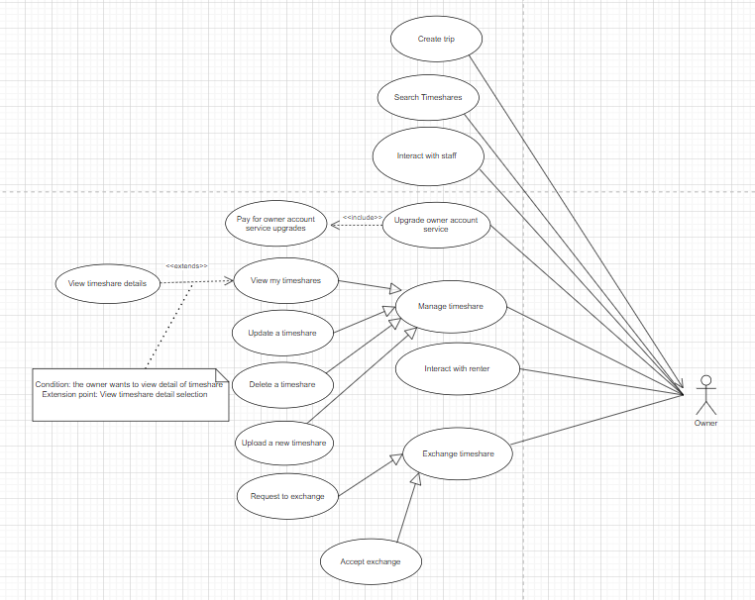

#### **2.4.17 Upload new timeshare**

| **USE CASE-17 SPECIFICATION** | | | |
| --- | --- | --- | --- |
| **Use-case No.** | UC17 | **Use-case Version** | 1.0 |
| **Use-case Name** | Upload new timeshare | | |
| **Author** | Đoàn Dương Minh Trí | | |
| **Date** | 23/02/2024 | **Priority** | High |
| **Actor:**  Owner  **Summary:**        This use case involves owners uploading their own timeshare on the platform for renting or exchanging.  **Goal:**        Enable actors to successfully upload their timeshare to the platform.  **Triggers**              The actor wants to upload a new timeshare.  **Preconditions:**   * The actor has logged in by an owner account.   **Post Conditions:**   * **Success:** System shows a message dialog with a successful message when the timeshare has been created successfully in the database.   **Main Success Scenario:**   | **Step** | **Actor action** | **System Response** | | --- | --- | --- | | 1 | Go to the homepage, click on the "Upload new timeshare" button in the navigation bar on top of page.  **[Alternative 1]** | System presents the form for entering timeshare details, including:  - Resort: dropdown list, resort object:  + Name: string  + Location: string  + Description: string  + Facilities: string[] (features of resort)  + Nearby attractions: string[]  + Policies: string[] (policies of resort)  + Image URLs: string[]  + Units: Unit[] (resort has many unit or room type)  - Unit: dropdown list, unit object:  + Room name: String  + Details: String  + Image URLs: String[]  + ResortId: String  - Start-date: date input dd/mm/yyyy (Calendar picker for selecting the start date)  - End-date: date input dd/mm/yyyy (Calendar picker for selecting the end date)  - Images: File[] (Ability to upload multiple images of the timeshare, thumbnail preview for each uploaded image)  - Price:  + Amount: Number,  + Currency: String (dropdown list, required options: USD, EUR, VNĐ, etc.) (Pricing details for the timeshare)  - Additional fees: Number | | 2 | The actor clicks the “Save” button. | System saves a timeshare and shows the message “Upload timeshare successfully”.  **[Exception 1, 2, 3, 4, 5, 6, 7, 8, 9, 10]** |   **Alternative Scenario:**   | **No.** | **Actor action** | **System Response** | | --- | --- | --- | | 1 | Go to "User dashboard". Go to the “Manage timeshares section”. Click on “Upload new timeshare” | System presents the form for entering timeshare details, including:  - Resort: dropdown list, resort object:  + Name: string  + Location: string  + Description: string  + Facilities: string[] (features of resort)  + Nearby attractions: string[]  + Policies: string[] (policies of resort)  + Image URLs: string[]  + Units: Unit[] (resort has many unit or room type)  - Unit: dropdown list, unit object:  + Room name: String  + Details: String  + Image URLs: String[]  + ResortId: String  - Start-date: date input dd/mm/yyyy (Calendar picker for selecting the start date)  - End-date: date input dd/mm/yyyy (Calendar picker for selecting the end date)  - Images: File[] (Ability to upload multiple images of the timeshare, thumbnail preview for each uploaded image)  - Price:  + Amount: Number,  + Currency: String (dropdown list, required options: USD, EUR, VNĐ, etc.) (Pricing details for the timeshare)  - Additional fees: Number | | 2 | The actor clicks the “Save” button. | System saves a timeshare and shows the message “Upload timeshare successfully”.  **[Exception 1, 2, 3, 4, 5, 6, 7, 8, 9, 10]** |   **Exceptions:**   | **No.** | **Actor Action** | **System Response** | | --- | --- | --- | | 1 | If Resort is not selected | System informs: "Please select a resort from the dropdown list." | | 2 | If Unit is not selected | System informs: "Please select a unit from the dropdown list." | | 3 | If Start date is not selected | System informs: "Please choose a start date for the timeshare." | | 4 | If End date is not selected | System informs: "Please choose an end date for the timeshare." | | 5 | If End date is not after Start date | System informs: "End date must be after the start date." | | 6 | If Images are not uploaded | System informs: "Please upload at least one image of the timeshare." | | 7 | If Price is not provided | System informs: "Please enter the pricing details for the timeshare." | | 8 | If Currency is not selected | System informs: "Please select the currency for pricing." | | 9 | If Image file is bigger than 10MB | System informs: "Please ensure that each uploaded image is no larger than 10MB." | | 10 | If Unit does not belong to the selected resort | System informs: "The selected unit does not belong to the chosen resort." |   **Relationships:**             UC-15: Login  **Business Rules:**   * Owner must login to upload timeshares. * Start date must be before end date * Pricing details should be consistent and within acceptable ranges. * Contact information of members is masked to ensure privacy until a rental or exchange request is accepted. | | | |
|  | | | |

#### **2.4.18 View my timeshares**

| **USE CASE-18 SPECIFICATION** | | | |
| --- | --- | --- | --- |
| **Use-case No.** | UC18 | **Use-case Version** | 1.0 |
| **Use-case Name** | View my timeshares | | |
| **Author** | Đoàn Dương Minh Trí | | |
| **Date** | 23/02/2024 | **Priority** | High |
| **Actor:**  Owner  **Summary:**        This use case involves owners viewing their own timeshares on the platform.  **Goal:**        Enable owners to successfully view their timeshares on the platform.  **Triggers**   * The owner wants to view their own timeshare.   **Preconditions:**   * The owner has logged in with their owner account.   **Post Conditions:**   * **Success:** Owners view the details of their own uploaded timeshares.   **Main Success Scenario:**   | **Step** | **Actor action** | **System Response** | | --- | --- | --- | | 1 | In the user dashboard, navigate to the "Manage timeshares" tab in the left side of the dashboard. | Redirect to page that display the list of the timeshares card overview that include some information:  - Resort name  - Room type  - Start date  - Start date  - Price  - Status  **[Exception 1]** |   **Alternative Scenario:** N/A  **Exceptions:**   | **No.** | **Actor and Action** | **System Response** | | --- | --- | --- | | 1 | The owner has no timeshare. | Show a “Upload new timeshare” button. |   **Relationships:**   * UC-15: Login * UC-24: View timeshare details   **Business Rules:**   * Timeshares can only be viewed by their owners. * To maintain privacy, the owner's sensitive information is hidden. | | | |

### 

#### **2.4.19 Update a timeshare**

| **USE CASE-19 SPECIFICATION** | | | |
| --- | --- | --- | --- |
| **Use-case No.** | UC19 | **Use-case Version** | 1.0 |
| **Use-case Name** | Update a timeshare | | |
| **Author** | Đoàn Dương Minh Trí | | |
| **Date** | 23/02/2024 | **Priority** | High |
| **Actor:**  Owner  **Summary:**        This feature allows owners to update detailed information about their timeshares.  **Goal:**        Enable owners to easily and accurately update information associated with their timeshares.  **Triggers**   * The owner wants to update detailed information about their timeshare.   **Preconditions:**   * The owners are logged into the system. * The owner has at least one timeshare listing associated with their account. * The owners are currently in “My timeshares” in the left tab of Dashboard page’s screen.   **Post Conditions:**   * **Success:** System shows a dialog with a message “Update timeshare successfully” when the timeshare has been updated successfully in the database.   **Main Success Scenario:**   | **Step** | **Actor action** | **System Response** | | --- | --- | --- | | 1 | The owner clicks on the “Edit” button in the Timeshare’s detail row/card. | System redirects to update timeshare page with a form with these fields:  - Resort: dropdown list, resort object:  + Name: string  + Location: string  + Description: string  + Facilities: string[] (features of resort)  + Nearby attractions: string[]  + Policies: string[] (policies of resort)  + Image URLs: string[]  + Units: Unit[] (resort has many unit or room type)  - Unit: dropdown list, unit object:  + Room name: String  + Details: String  + Image URLs: String[]  + ResortId: String  - Start date: date input dd/mm/yyyy (Calendar picker for selecting the start date)  - End date: date input dd/mm/yyyy (Calendar picker for selecting the end date)  - Images: File[] (Ability to upload multiple images of the timeshare, thumbnail preview for each uploaded image)  - Price:  + Amount: Number,  + Currency: String (dropdown list, required options: USD, EUR, VNĐ, etc.) (Pricing details for the timeshare)  - Additional fees: Number | | 2 | The owner clicks on the “View preview” button. | System shows a preview dialog with full timeshare details.  **[Exception 1, 2, 3, 4, 5, 6, 7, 8, 9, 10]** | | 3 | The owner clicks on the “Save” button on the preview dialog.  **[Alternation 2]** | System will create and save data of the timeshare to the database then show a message “Update timeshare successfully” on the popup dialog. |   **Alternative Scenario:**   | **No.** | **Actor action** | **System Response** | | --- | --- | --- | | 1 | The owner clicks on the “Cancel” button on the preview dialog. | Preview dialog is hidden, and the update timeshare form is focused again. |   **Exceptions:**   | **No.** | **Actor action** | **System Response** | | --- | --- | --- | | 1 | If Resort is not selected | System informs: "Please select a resort from the dropdown list." | | 2 | If Unit is not selected | System informs: "Please select a unit from the dropdown list." | | 3 | If Start date is not selected | System informs: "Please choose a start date for the timeshare." | | 4 | If End date is not selected | System informs: "Please choose an end date for the timeshare." | | 5 | If End date is not after Start date | System informs: "End date must be after the start date." | | 6 | If Images are not uploaded | System informs: "Please upload at least one image of the timeshare." | | 7 | If Price is not provided | System informs: "Please enter the pricing details for the timeshare." | | 8 | If Currency is not selected | System informs: "Please select the currency for pricing." | | 9 | If Image file is bigger than 10MB | System informs: "Please ensure that each uploaded image is no larger than 10MB." | | 10 | If Unit does not belong to the selected resort | System informs: "The selected unit does not belong to the chosen resort." |   **Relationships:**   * UC-15: Login     **Business Rules:**  - Timeshare can only be updated by the owner who created it.  - Cannot update the timeshare which has been rented or exchanged  - Cannot update the timeshare which is in processing (waiting for acceptance, has reservation, …) | | | |

#### **2.4.20 Delete a timeshare**

| **USE CASE-20 SPECIFICATION** | | | |
| --- | --- | --- | --- |
| **Use-case No.** | UC20 | **Use-case Version** | 1.0 |
| **Use-case Name** | Delete a timeshare | | |
| **Author** | Đoàn Dương Minh Trí | | |
| **Date** | 23/02/2024 | **Priority** | Normal |
| **Actor:**  Owner  **Summary:**        This use case involves an owner deleting one of their timeshare.  **Goal:**        The owner indicates a desire to delete one of their timeshare.  **Triggers**   * The actor wants to delete their own timeshare.   **Preconditions:**   * The actor has logged in with their owner account. * The actor has at least one active timeshare on the platform. * The owners are currently in “My timeshares” in the left tab of Dashboard page’s screen.   **Post Conditions:**   * **Success:** Timeshare is successfully deleted from the platform.   **Main Success Scenario:**   | **Step** | **Actor action** | **System Response** | | --- | --- | --- | | 1 | Click on the "Delete timeshare" button. | - Asks for confirmation “Are you sure to delete this timeshare ?”  - Show button “Confirm” and “Cancel” | | 3 | Confirm to delete.  **[Alternative 1]** | - Delete the timeshare if the actor confirms.  **[Exception 1]**  **[Exception 2]** | | 4 | System shows a success message "Timeshare deleted." | - Show message dialog “Timeshare has been deleted” |   **Alternative Scenario:**   | **No.** | **Actor action** | **System Response** | | --- | --- | --- | | 1 | Owner decides not to delete the timeshare. | System cancels the deletion process and returns to the list of timeshares. |   **Exceptions:**   | **No.** | **Actor and Action** | **System Response** | | --- | --- | --- | | 1 | Owner is not logged in. | System prompts the actor to log in before proceeding with the timeshare deletion. |   **Relationships:**   * UC-13: Login * UC-18: View my timeshares   **Business Rules:**   * A timeshare can only be deleted by its owner. * Soft deletion hides the timeshare from the owner and regular users but remains visible for admin and staff. | | | |

#### **2.4.21 Upgrade Owner Account Service**

| **USE CASE-21 SPECIFICATION** | | | |
| --- | --- | --- | --- |
| **Use-case No.** | UC21 | **Use-case Version** | 1.0 |
| **Use-case Name** | Upgrade Owner Account Service | | |
| **Author** | Đoàn Dương Minh Trí | | |
| **Date** | 23/02/2024 | **Priority** | Normal |
| **Actor:**              Owner  **Summary:**        This use case involves an owner upgrading their account service by paying a fee to access premium services.  **Goal:**        Enable owners to successfully upgrade their account service by making a payment.  **Triggers:**   * The owner indicates a desire to upgrade their account service.   **Preconditions:**   * Owner is logged into the system.   **Post Conditions:**   * **Success:** Owner's account service is successfully upgraded, and the payment transaction is recorded.   **Main Success Scenario:**   | **Step** | **Actor action** | **System Response** | | --- | --- | --- | | 1 | Owner accesses the platform and navigates to the "Upgrade account service" section. | System presents available account service upgrade options and associated costs. | | 2 | Owner selects the desired account service upgrade option and initiates the payment process. | System redirects the owner to a secure payment gateway. | | 3 | Owner completes the payment transaction with the necessary payment details.  **[Alternative 1]** | System verifies the payment and updates the owner's account service to the upgraded level.  **[Exception 1]** | | 4 | System notifies the owner of the successful account service upgrade. | Owner receives a confirmation message indicating the successful upgrade and any additional benefits gained. |   **Alternative Scenario:**   | **Step** | **Actor action** | **System Response** | | --- | --- | --- | | 1 | Owner encounters payment transaction errors. | System prompts the owner to review and correct the payment details or choose an alternative payment method. | | 2 | Owner corrects errors and resubmits the payment transaction. | System revalidates the payment information, completes the transaction if successful, and notifies the owner of the successful upgrade. |   **Exceptions:**   | **No.** | **Actor and Action** | **System Response** | | --- | --- | --- | | 1 | Technical issues during the payment process. | System displays an error message and advises the owner to try again. |   **Relationships:**   * UC-13: Login   **Business Rules:**  - Only registered owners with valid accounts ( not in blacklist, email verified ) can upgrade their account service.  - Payment details must be valid and processed securely.  - Upgraded account service benefits are provided immediately after a successful payment. | | | |

#### **2.4.22 Owner Interact with Renters**

| **USE CASE-22 SPECIFICATION** | | | |
| --- | --- | --- | --- |
| **Use-case No.** | UC22 | **Use-case Version** | 1.0 |
| **Use-case Name** | Interact with renters | | |
| **Author** | Đoàn Dương Minh Trí | | |
| **Date** | 23/02/2024 | **Priority** | Normal |
| **Actor:**              Owner  **Summary:**        This use case involves an owner interacting with renters who request to rent or exchange their timeshare.  **Goal:**        Enable owners to interact with renters, providing information, and managing timeshare transactions.  **Triggers**   * The owner indicates to interact with renters or respond to renters.   **Preconditions:**   * Owner is logged into the system. * Owner has at least one timeshare.   **Post Conditions:**   * **Success:** System displays chatbox between owner and customer (renter, exchange).   **Main Success Scenario:**   | **Step** | **Actor action** | **System Response** | | --- | --- | --- | | 1 | Owner accesses the platform and navigates to the "Renter interactions" or "My messages" section. | System retrieves and displays a list of Renter inquiries or messages related to the owner's timeshare posts. | | 2 | Owner selects a specific conversation. | - System presents the details of the conversation, including:   * Owner information * Customer information * Messages | | 3 | Owner responds to the renter, providing information, answering questions, or managing the timeshare transaction. | - System updates the communication thread  - Notifies the renter of the owner's response. |   **Alternative Scenario:**   | **No.** | **Actor action** | **System Response** | | --- | --- | --- | | 1 | Owner has no renter’s inquiries or messages. | System displays a message indicating that there are no renter interactions at the moment. |   **Exceptions:**   | **No.** | **Actor and Action** | **System Response** | | --- | --- | --- | | 1 | Owner is not logged in. | System prompts the owner to log in before accessing renter interactions. | | 2 | Technical issues during the retrieval or response process. | System displays an error message and advises the owner to try again. |   **Relationships:**   * UC-13: Login   **Business Rules:**   * Only owners can interact with renters. * Renter inquiries or messages should be displayed in a clear and organized manner. * Owner responses should be timely and provide relevant information. * Real-time chatting between owner and customer | | | |

#### **2.4.23 View timeshare details**

| **USE CASE-23 SPECIFICATION** | | | |
| --- | --- | --- | --- |
| **Use-case No.** | UC23 | **Use-case Version** | 1.0 |
| **Use-case Name** | View timeshare details | | |
| **Author** | Đoàn Dương Minh Trí | | |
| **Date** | 23/02/2024 | **Priority** | High |
| **Actor:**              Owner, Renter, Guest.  **Summary:**        This feature allows actors to view timeshare with detailed information  **Goal:**        Enable members to successfully view a timeshare in detail.  **Triggers**   * The actor wants to view a timeshare in detail.   **Preconditions:**   * Actors are logged into the system.   **Post Conditions:**   * **Success:** Show detailed information of each timeshare as a card view.   **Main Success Scenario:**   | **Step** | **Actor action** | **System Response** | | --- | --- | --- | | 1 | Actors access the platform and navigate to the "Manage timeshares" section. | System presents a list of existing timeshare associated with the member's account.  **[Exception 1]** | | 2 | Actors select the timeshare to view detail. | Opens a detailed view of the selected timeshare including fields:  + Resort: name, location, description, facilities, nearby attractions, policies, images  + Unit: Room name, details, image  + Start date  +End date  + Images  +Price  +Additional fees  + Status: (was rented or was exchanged) |   **Alternative Scenario: N/A**  **Exceptions: N/A**  **Relationships:**   * UC-13: Login * UC-01: Search Timeshares   **Business Rules:**   * Privacy information (personal information of owner) should be hidden. * Request button must be disabled after the timeshare end of process (was rented or was exchanged) | | | |

#### **2.4.24 Accept the timeshare exchange request**

| **USE CASE-24 SPECIFICATION** | | | |
| --- | --- | --- | --- |
| **Use-case No.** | UC24 | **Use-case Version** | 1.0 |
| **Use-case Name** | Accept to exchange | | |
| **Author** | Đoàn Dương Minh Trí | | |
| **Date** | 23/02/2024 | **Priority** | High |
| **Actor:**              Owner  **Summary:**  This use case involves the owner accepting an incoming timeshare exchange request from another owner.  **Goal:**  Allows owners to accept to exchange timeshare.  **Triggers:**   * The owner indicates they want to accept an incoming timeshare exchange request.   **Preconditions:**   * Owner has received the exchange request from the other owner.   **Post Conditions:**   * **Success:** The actor has successfully accept the exchange request   **Main Success Scenario:**   | **Step** | **Actor action** | **System Response** | | --- | --- | --- | | 1 | The actor clicks on the "Manage timeshares" tab. Go to the “Exchange request” table. | The system retrieves and displays the list of timeshare exchange requests coming from other owners. The content contains an "Accept" button and a "Decline" button.  **[Exception 1]** | | 2 | The actor clicks the "Accept" button.  **[Alternative 1]** | The system returns an alert "Accept exchange request ? " and an "OK" button.  **[Exception 2]** | | 3 | Actor clicks the "OK" button or press Enter | The system displays the message "Accepted successfully.” Send notification email to the requester. | | 4 |  | Staff create trip for both owners based on information in exchange process:   * Resort name * Check in date * Check out date * Room information: * Room type * Room number * Resort contact: * Hotline * Email | |  |  |  |   **Alternative Scenario:**   | **No.** | **Actor action** | **System Response** | | --- | --- | --- | | 1 | The actor clicks the "Decline" button. | The notification system has sent a rejection email to the requester "Requester name". |   **Exceptions:**   | **No.** | **Actor and Action** | **System Response** | | --- | --- | --- | | 1 | The timeshare is not available (rented or has been exchanged) | The system returns "The timeshare is no longer available for exchange". |   **Relationships:**   * UC-13: Login * UC-01: Search Timeshares * UC-30: Create trip   **Business Rules:**   * The owner must own the timeshare under the correct owner. * Timeshare exchange requirements must be at the same level as the timeshare the renter currently owns. | | | |
|  | | | |

#### **2.4.25 Request to exchange**

| **USE CASE-25 SPECIFICATION** | | | |
| --- | --- | --- | --- |
| **Use-case No.** | UC25 | **Use-case Version** | 1.0 |
| **Use-case Name** | Request to exchange timeshare | | |
| **Author** | Đào Xuân Tịnh | | |
| **Date** | 23/02/2024 | **Priority** | High |
| **Actor:**  Owner.  **Summary:**        This use case involves owners who have their own timeshare initiating a request to exchange their timeshare.  **Goal:**        Enable owners to request exchanging their timeshare.  **Triggers**   * The owner indicates he/she wants to request exchanging their timeshare.   **Preconditions:**   * Actor is logged into the system.   **Post Conditions:**   * **Success:** The actor successfully submitted their timeshare exchange request.   **Main Success Scenario:**   | **Step** | **Actor action** | **System Response** | | --- | --- | --- | | 1 | The actor accesses the platform and clicks on the timeshare card. | The system retrieves and displays detailed information as:  - Thumbnail  - Name of the timeshare  - Code of the post  - Owner's name  - Room type  - Exchange time  - Check in time  - Check out time  - Price per night  - Total price  **[Exception 1]** | | 2 | The actor clicks on the "Request to exchange" button.  **[Alternative 1]** | The system displays a notification of successful request submission.  **[Exception 2]** |   **Alternative Scenario:**   | **No.** | **Actor action** | **System Response** | | --- | --- | --- | | 1 | The actor accesses the platform and searches for timeshares. | The system retrieves and displays detailed information of the timeshare.  **[Exception 3]** | | 2 | The actor accesses the platform and clicks on the timeshare card. | The system retrieves and displays detailed information of the timeshare.  **[Exception 1]** | | 3 | The actor clicks on the "Request To Exchange" button. | The system displays a notification of successful request submission.  **[Exception 2]** |   **Exceptions:**   | **No.** | **Actor and Action** | **System Response** | | --- | --- | --- | | 1 | The actor fails to access the platform. | System displays an error | | 2 | The actor fails to click on the "Request to exchange" button. | System does not proceed with the exchange request and displays an error message prompting the actor to try again. | | 3 | The actor fails to find any timeshares during the search. | System displays a message indicating no timeshares were found matching the search criteria. |   **Relationships:**   * UC-13: Login * UC-01: Search Timeshares   **Business Rules:**   * Only registered owners with valid accounts can request to exchange their timeshare. * The system should ensure the availability of detailed timeshare information before allowing the exchange request. | | | |

#### **2.4.26 Accept for renting**

| **USE CASE-14 SPECIFICATION** | | | |
| --- | --- | --- | --- |
| **Use-case No.** | UC14 | **Use-case Version** | 1.0 |
| **Use-case Name** | Request to exchange timeshare | | |
| **Author** | Nguyễn Trần Tấn Phát | | |
| **Date** | 23/02/2024 | **Priority** | High |
| **Actor:**  Owner.  **Summary:**        This use case involves owners who have their own timeshare initiating a request to exchange their timeshare.  **Goal:**        Enable owners to request another owner to exchange timeshare.  **Triggers**   * The owner indicates he/she wants to request exchanging their timeshare.   **Preconditions:**   * Actor is logged into the system.   **Post Conditions:**   * **Success:** The actor successfully submitted their timeshare exchange request.   **Main Success Scenario:**   | **Step** | **Actor action** | **System Response** | | --- | --- | --- | | 1 | The actor accesses the platform and clicks on the timeshare card. | The system retrieves and displays detailed information as :  - Thumbnail  - Name of the timeshare  - Code of the post  - Owner's name  - Unit  - Exchange time  - Check in time  - Check out time  - Price per night  - Total amount  **[Exception 1]** | | 2 | The actor clicks on the "Request to exchange" button.  **[Alternative 1]** | The system displays a notification of successful request submission.  **[Exception 2]** |   **Alternative Scenario:**   | **No.** | **Actor action** | **System Response** | | --- | --- | --- | | 1 | The actor accesses the platform and searches for timeshares. | The system retrieves and displays detailed information of the timeshare.  **[Exception 3]** | | 2 | The actor accesses the platform and clicks on the timeshare card. | The system retrieves and displays detailed information of the timeshare.  **[Exception 1]** | | 3 | The actor clicks on the "Request To Exchange" button. | The system displays a notification of successful request submission.  **[Exception 2]** |   **Exceptions:**   | **No.** | **Actor and Action** | **System Response** | | --- | --- | --- | | 1 | The actor fails to access the platform. | System displays an error | | 2 | The actor fails to click on the "Request To Exchange" button. | System does not proceed with the exchange request and displays an error message prompting the actor to try again. | | 3 | The actor fails to find any timeshares during the search. | System displays a message indicating no timeshares were found matching the search criteria. |   **Relationships:**   * UC-13: Login * UC-01: Search Timeshares   **Business Rules:**   * Only registered owners with valid accounts can request to exchange their timeshare. * The system should ensure the availability of detailed timeshare information before allowing the exchange request. | | | |

## 

### **2.4 Admin**

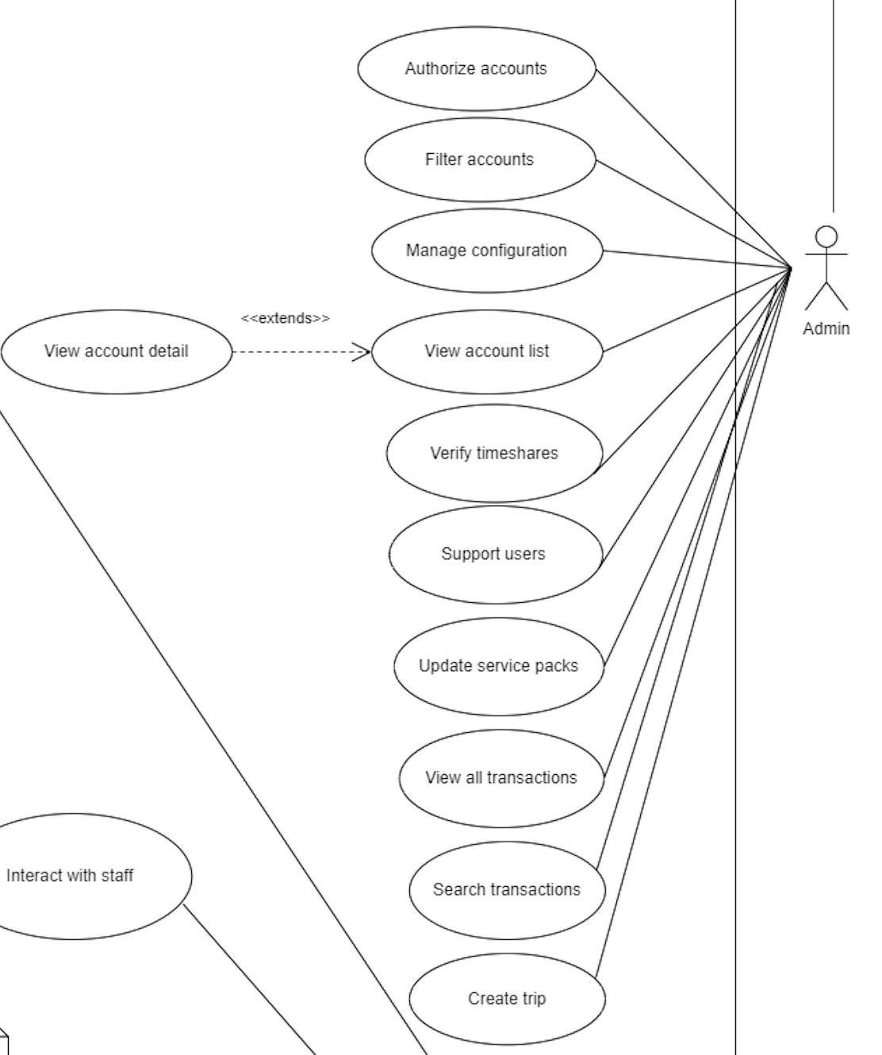

### 

#### **2.4.27 Support User**

| **USE CASE-27 SPECIFICATION** | | | |
| --- | --- | --- | --- |
| **Use-case No.** | UC27 | **Use-case Version** | 1.0 |
| **Use-case Name** | Support users | | |
| **Author** | Đỗ Huỳnh Nguyên Vũ | | |
| **Date** | 24/02/2024 | **Priority** | Normal |
| **Actor:**  Staff  **Summary:**        Staff support system issues with owners or renters.  **Goal:**          The goal of this use case is for support staff to effectively resolve system-related issues reported by owners or renters.  **Triggers**  This use case is indicated when an owner or tenant reports a system problem or seeks support.  **Preconditions:**         PRE-1. The staff member has logged into the support system.             PRE-2. There is a reported issue or request for support from an owner or a renter.  **Post Conditions:**         POST-1. The reported issue or request is resolved.  **Main Success Scenario:**   | **Step** | **Actor Action** | **System Response** | | --- | --- | --- | | 1 | Staff log in to the web application system with their staff account. | The system redirects to the Home page for staff accounts, on the left is the dashboard:  - Support users  - Search a transaction  - Update service packs  - View all transactions | | 2 | The staff clicks on "Support user" | The system switches the page to "Chat system" with a list of users appearing and on the right is a chat frame. The user with the latest request will be pushed to the top of the list, and users who have not responded will be displayed in bold font. | | 3 | The staff clicks on any user and enters a message with support content and press enter. | The system will display staff messages in the chat frame.  [Exception 1] | | 4 | The staff clicks on the phone image on the chat box.. | The system will redirect to the call page including Avatar’s user, time of call and red call button to exit the call.  [Exception 2] | | 5 | The staff clicks on the red phone button below to end the call with the user who needs support. | The system will return to the original chat frame page with the calling user. | | 6 | The staff clicks on the return sign at the top left of the chat frame | The system redirects back to the Staff Home page. |   **Alternative Scenario:**  None  **Exceptions**:   | **No.** | **Actor Action** | **System Response** | | --- | --- | --- | | 1 | If the message contains inappropriate characters, it will not be sent. | The system returns the chat frame to still display the sent message but will include a yellow notification line below "Inappropriate message". | | 2 | Network connection problem when calling. | Time will now freeze and the website will display the message "Network error - Need to reconnect to the internet". |   **Relationships:**       - UC-13: Login  **Business Rules:**      - Staff must prioritize and address reported issues within a reasonable time frame.      - Communication with owners should be clear, concise, and respectful. | | | |

#### **2.4.28 Update service packs**

| **USE CASE-28 SPECIFICATION** | | | |
| --- | --- | --- | --- |
| **Use-case No.** | UC28 | **Use-case Version** | 1.0 |
| **Use-case Name** | Update service packs | | |
| **Author** | Đỗ Huỳnh Nguyên Vũ | | |
| **Date** | 27/02/2024 | **Priority** | High |
| **Actor:**  Staff.  **Summary:**        Update service packages (including prices, services and newly updated features).  **Goal:**          The goal of this use case is to enable staff to update service packages, including adjusting prices, modifying services, and incorporating newly updated features.  **Triggers**     The need to modify or update information related to service packages.  **Preconditions:**         PRE-1: The staff member must be logged into the system.  **Post Conditions:**              POST-1: Staff successfully updates the information about the selected service packages.  **Main Success Scenario:**   | **Step** | **Actor Action** | **System Response** | | --- | --- | --- | | 1 | Staff logs into the system. | The system redirects to the Home page for staff accounts, on the left is a list of staff function options :  - Support users  - Search a transaction  - Update service packs  - View all transactions | | 2 | Staff navigates to the "Update Service Packs" section. | The system displays the system's service packages on the page as a table with the following fields:        - Service package name        - Price        - Role        - Detailed description of services and features included in the package.        - Update button. | | 3 | The staff clicks on the fields that need to edit the service package and click Update. | The system displays the message "Are you sure you want to update the service package information", the "OK" button and the "Cancel" button. | | 4 | The staff clicks the "OK" button. | The system returns to the "Update service pack" page and the table displays that the page's information has been updated. |   **Alternative Scenario:**  None.  **Exceptions:**   | **No.** | **Actor Action** | **System Response** | | --- | --- | --- | | 1 | If the staff is unable to log in, an error message is displayed. | System shows an error message, prompting staff to retry login or seek assistance. | | 2 | If there is an issue retrieving or updating service package data, an error message is displayed. | System generates an error message, notifying staff of the issue and suggesting a retry or contacting support. |   **Relationships:**       - This use case may be related to other use cases UC15 (Login) .  **Business Rules:**       - Only staff members with the appropriate permissions can update service packages.      - Updates made to service package information should be validated for accuracy.      - Changes in prices or services should be communicated to relevant stakeholders. | | | |

### 

#### **2.4.29 View All Transactions**

| **USE CASE-29 SPECIFICATION** | | | |
| --- | --- | --- | --- |
| **Use-case No.** | UC29 | **Use-case Version** | 1.0 |
| **Use-case Name** | View all transactions | | |
| **Author** | Đỗ Huỳnh Nguyên Vũ | | |
| **Date** | 27/02/2024 | **Priority** | High |
| **Actor:**  Staff  **Summary:**        Staff can view all transactions between all owners and all renters  **Goal:**          The goal of this use case is to enable staff members to view all transactions between owners and Renters in the system.  **Triggers**            The need to access and review transaction information between owners and Renters.  **Preconditions:**         PRE-1: The staff member must be logged into the system..  **Post Conditions:**              POST-1: Staff successfully views all transactions between owners and Renters.  **Main Success Scenario:**   | **Step** | **Actor Action** | **System Response** | | --- | --- | --- | | 1 | Staff logs into the system.  [Exception 1] | * The system redirects to the Home page for staff accounts, on the left is a list of staff function options : * - Support users * - Search a transaction * - Update service packs * - View all transactions | | 2 | Staff clicks on the " All Transactions" button. | The system displays transactions including the fields:   * Order * Order Detail * Renter Id * Renter Name * Owner Id * Owner Name * Fee * Payment. | | 3 | The staff clicks the back button. | The system redirects to the home page. |   **Alternative Scenario:**  None.  **Exceptions:**   | **No.** | **Actor Action** | **System Response** | | --- | --- | --- | | 1 | If the staff is unable to log in, an error message is displayed. | System shows an error message, prompting staff to retry login or seek assistance. |   **Relationships:**     - This use case may be related to other use cases UC14 (Login) depending on the integration of services and features.  **Business Rules:**      - Only staff members with the appropriate permissions can view transactions.              - Transaction data should be regularly updated in the system to ensure accuracy. | | | |

#### **2.4.30 Create trip**

| **USE CASE-20 SPECIFICATION** | | | |
| --- | --- | --- | --- |
| **Use-case No.** | UC20 | **Use-case Version** | 1.0 |
| **Use-case Name** | Create trip | | |
| **Author** | Đỗ Huỳnh Nguyên Vũ | | |
| **Date** | 23/02/2024 | **Priority** | High |
| **Actor:**  Staff  **Summary:**        This use case involves staff creating trips for customers.  **Goal:**        Enable owners to successfully create trips after the rent or exchange process is completed.  **Triggers**   * The staff wants to create trips for customers.   **Preconditions:**   * The staff has logged in with their staff account.   **Post Conditions:**   * **Success:** Staff successfully create trips for customers.   **Main Success Scenario:**   | **Step** | **Actor action** | **System Response** | | --- | --- | --- | | 1 | In the staff dashboard, navigate to the "Create trip" tab in the left side of the dashboard. | System show based information on display:  - Rent ID: input type: string  - Resort name: input type: string  - Check in date: input type: date  - Check out date input type: date  - Room information:   * Room type: input type: string * Room number: input type: string   - Resort contact:   * Hotline: input type: string * Email: input type: string   **[Exception 1]** | | 2 | Actor click button “Submit” | Send trip notification to renter. |   **Alternative Scenario:**   | **Step** | **Actor action** | **System Response** | | --- | --- | --- | | 1 | In the staff dashboard, navigate to the "Create trip" tab in the left side of the dashboard. | System show based information on display:  - Exchange ID: input type: string  - Resort name: input type: string  - Check in date: input type: date  - Check out date input type: date  - Room information:   * Room type: input type: string * Room number: input type: string   - Resort contact:   * Hotline: input type: string * Email: input type: string   **[Exception 1]** | | 2 | Actor click button “Submit” | Send trip notification to both owners. |   **Exceptions:** N/A  **Relationships:**   * UC: 26   **Business Rules:**   * Trip can only be viewed by their owner or renter. | | | |

#### **2.4.31 Verify timeshare**

| **USE CASE-20 SPECIFICATION** | | | |
| --- | --- | --- | --- |
| **Use-case No.** | UC31 | **Use-case Version** | 1.0 |
| **Use-case Name** | Verify timeshare | | |
| **Author** | Đỗ Huỳnh Nguyên Vũ | | |
| **Date** | 23/02/2024 | **Priority** | High |
| **Actor:**  Staff  **Summary:**        This use case involves staff verifying timeshare was posted on the platform.  **Goal:**        Enable owners to successfully verify timeshare after the owners post on the platform.  **Triggers**   * The staff wants to verify timeshare.   **Preconditions:**   * The staff has logged in with their staff account.   **Post Conditions:**   * **Success:** Staff successfully verify timeshare.   **Main Success Scenario:**   | **Step** | **Actor action** | **System Response** | | --- | --- | --- | | 1 | In the staff dashboard, navigate to the "View timeshares" tab in the left side of the dashboard. Click on a specific timeshare. | Show dialog have two option “Accept timeshare”, “Decline timeshare”  **[Alternative 1]** | | 2 | Staff clicks on “Accept timeshare” | The system notifies the renter that "Timeshare has been successfully verified" and uploads the timeshare to the homepage. |   **Alternative Scenario:**   | **Step** | **Actor action** | **System Response** | | --- | --- | --- | | 1 | Staff clicks on “Decline timeshare” | The system notifies and send email to owner “Your timeshare was declined” |   **Exceptions:** N/A  **Relationships:**   * UC-13: Login * UC-19: Upload new timeshare   **Business Rules:**  N/A | | | |

## 

### 

#### **2.4.32 Authorize Account**

| **USE CASE-31 SPECIFICATION** | | | |
| --- | --- | --- | --- |
| **Use-case No.** | UC31 | **Use-case Version** | 1.0 |
| **Use-case Name** | Authorize Account | | |
| **Author** | Nguyễn Hoàng Phúc | | |
| **Date** | 23/02/2024 | **Priority** | High |
| **Actor:**  Admin  **Summary:**        The “Authorize account” use case involves granting access to a user or system based on certain conditions.  **Goal:**        The primary goal of the “Authorize account” use case is to verify the identity and permissions of the entity seeking access.  **Triggers**          The trigger is the event that initiates the use case.  **Preconditions:**             PRE-1: The Admin login is authenticated and has the necessary permissions.  **Post Conditions:**         POST-1: User gains access to authorized features after authorization.  **Main Success Scenario:**   | **No.** | **Actor Action** | **System Response** | | --- | --- | --- | | 1 | The Admin logs into the system.  [Exception 1] | * The system verifies the administrator's credentials and grants access. * The system displays the Admin home page with on the left a list of settings options for the Admin page including:   - Dashboard  - User Management  - Configuration Management. | | 2 | Administrators navigate to the “User Management” page. | * The system redirects to the User management page. * The user management page appears with a search box, user filtering options and a user table including the field: * UserId (int) * UserName (String) * Password (String) * Gmail (String) * NumberOfPhone (String) * Number of times reported. (int) * Role_id (int) * Details (Button). * Ban (Button). | | 3 | The actor clicks the "Details" button to display the value in the row of the user that the actor wants to see details about. | The system redirects to that user's detail page with information displayed in the form including:   * UserId (int) * UserName (String) * Password (String) * Gmail (String) * NumberOfPhone (String) * Number of times reported. (int) * Role_id (int) * Update (Button). | | 4 | The administrator re-enters the  user's role_id and clicks Update | The administrator re-enters the user's information and clicks Update  The system displays the message   * "Are you sure you want to update this account's authorization information?" * Ok button * Cancel button | | 5 | The administrator clicks on the OK button | The system returns user information with the changed Role_Id. |   **Alternative Scenario:**     | **Step** | **Actor Action** | **System Response** | | --- | --- | --- | | 1 | Admin logs into the system. | * The system verifies the administrator's credentials and grants access. * The system displays the Admin home page with on the left a list of settings options for the Admin page including Chart, User Management, Configuration Management. | | 2 | Administrators navigate to the User Management page. | * The system redirects to the User management page. * The user management page appears with a Search box, User filtering options and a User table including the field: * UserId (int) * UserName (String) * Password (String) * Gmail (String) * NumberOfPhone (String) * Role_id * Number of times reported.. () * Update * Delete | | 3 | The administrator searches for the user's username | The system displays the user account. | | 4 | The administrator re-enters the  user's Role_id and clicks “Update  ”. | The administrator re-enters the user's information and clicks Update  The system displays the message   * "Are you sure you want to update this account's authorization information?" * Ok button * Cancel button | | 5 | The administrator clicks on the “Cancel” button | The system returns user information with the Role_Id not changed. |   **Exceptions:**   | **No.** | **Actor Action** | **System Response** | | --- | --- | --- | | 1 | System is not operational. | Error message is displayed, indicating the system issue. | | 2 | Admin lacks necessary permissions. | Error message is displayed, informing the admin of the permission issue. |   **Relationships:**             None.  **Business Rules:**      - The account status should be updated promptly to ensure accurate user activity tracking.              - Only authorized Admin users are allowed to perform account status updates. | | | |

#### **2.4.33 Filter Account**

| **USE CASE-32 SPECIFICATION** | | | |
| --- | --- | --- | --- |
| **Use-case No.** | UC32 | **Use-case Version** | 1.0 |
| **Use-case Name** | Filter Account | | |
| **Author** | Nguyễn Hoàng Phúc | | |
| **Date** | 23/02/2024 | **Priority** | High |
| **Actor:**  Admin  **Summary:**        Filter and search to find the account that meets your needs  **Goal:**        To efficiently locate and filter user accounts based on role.  **Triggers**          The need to search and filter user accounts based on specified conditions.  **Preconditions:**         PRE-1. The Admin is authenticated and has the necessary permissions.              PRE-2. The system is operational and connected to the user account database.  **Post Conditions:**         POST-1. The system displays a filtered list of accounts based on the specified criteria.              POST-2. Admin can view the details of the selected filtered accounts.  **Main Scenario:**   | **No.** | **Actor Action** | **System Response** | | --- | --- | --- | | 1 | Administrator logs into the system. | * The system verifies the administrator's credentials and grants access. * The system displays the Admin home page with on the left a list of settings options for the Admin page including Dashboard, User Management, Configuration Management. | | 2 | Admin click on User Management | * The system redirects to the User management page. * The user management page appears with a Search box, User filtering options and a User table including the field: * UserId (int) * UserName (String) * Password (String) * Gmail (String) * NumberOfPhone (String) * Number of times reported. (int) * Role_id (int) * Update (Button). * Ban(Button). | | 3 | Administrator ticks the filter button | The system returns 4 more options under the filter button:       - Admin       - Staff       - Owner       - Renter | | 4 | Renter chooses 1 of 4 options | The system will reload the page and display a table of all users belonging to that role |   **Alternative Scenario:**         None.  **Exceptions:**     | **No.** | **Actor Action** | **System Response** | | --- | --- | --- | | 1 | Admin fails to log in. | Use case terminates with an authentication error. | | 2 | Identified user account does not exist. | System notifies the admin of a non-existent account. | | 3 | Deletion process fails due to technical issues. | Error message is displayed, indicating the failure. |   **Relationships:**                  This use case may relate to other use cases involving account management, "Update Account."  **Business Rules:**                   Efficient filtering should be provided to help Admin quickly locate accounts.                  Only authorized Admin users are allowed to perform account filtering. | | | |

#### **2.4.34 Manage Configuration**

| **USE CASE-33 SPECIFICATION** | | | | |
| --- | --- | --- | --- | --- |
| **Use-case No.** | UC33 | **Use-case Version** | | 1.0 |
| **Use-case Name** | Manage configuration | | | |
| **Author** | Nguyễn Hoàng Phúc | | | |
| **Date** | 23/02/2024 | **Priority** | High | |
| **Actor:**  Admin  **Summary:**      The use case involves the actor managing system configurations.  **Goal:**      The goal of this use case is to enable the actor to manage various configurations within the system.  **Triggers**      The Admin initiates the configuration management action.  **Preconditions:**       1. The Admin must be logged into the system.       2. System configuration data must exist in the system.  **Post Conditions:**      The Admin successfully manages the system configurations.  **Main Success Scenario:**   | **Step** | **Actor Action** | **System Response** | | --- | --- | --- | | 1 | The Admin logs into the system. | * The system verifies the administrator's credentials and grants access. * The system displays the Admin home page with on the left a list of settings options for the Admin page including Dashboard, User Management, Configuration Management. | | 2 | The Admin navigates to the "Manage Configuration" section. | System presents a navigation menu, and Admin selects the specified section. | | 3 | The system provides options for managing configurations. | System displays a menu with configuration management options. | | 4 | The Admin makes necessary changes to configurations (e.g., update settings, parameters, etc.). | System provides interfaces for the Admin to modify configurations. | | 5 | The Admin confirms the changes. | System prompts for confirmation before applying updates. | | 6 | The system updates the configurations accordingly. | Database updated with new information; system confirms successful update. |   **Alternative Scenario:**          None.  **Exceptions:**   | **No.** | **Actor Action** | **System Response** | | --- | --- | --- | | 1 | If the Admin is unable to log in, an error message is displayed. | System shows an error message, prompting the Admin to retry login or seek assistance. | | 2 | If there is an issue retrieving or updating configuration data, an error message is displayed. | System generates an error message, notifying the Admin of the issue and suggesting a retry or contacting support. |     **Relationships:**  - This use case may be related to other use cases involving system administration.  **Business Rules:**  - Only Admins with the appropriate permissions can manage configurations.              - Changes to configurations should be validated for accuracy.  - System configurations should be regularly reviewed and updated as needed. | | | | |
|  |  |  |  |  |

#### **2.4.35 View account detail**

| **USE CASE-34 SPECIFICATION** | | | | |
| --- | --- | --- | --- | --- |
| **Use-case No.** | UC34 | **Use-case Version** | | 1.0 |
| **Use-case Name** | View account detail | | | |
| **Author** | Nguyễn Hoàng Phúc | | | |
| **Date** | 23/02/2024 | **Priority** | High | |
| **Actor:**  Admin  **Summary:**  This use case involves the admin viewing detailed information about a user account.  **Goal:**  The goal of this use case is to enable the admin to access and review specific details of a user account.  **Triggers:**  The Admin initiates the action to view the account details.  **Preconditions:**  PRE-1: The Admin must be logged into the system.  PRE-2: User account detail data must exist in the system.  **Post Conditions:**  **POST-1:** The Admin successfully views the detailed information of the user account.  **POST-2:** The system displays the requested user account details to the Admin.  **Main Success Scenario:**   | **Step** | **Actor Action** | **System Response** | | --- | --- | --- | | 1 | The Admin logs into the system.  [Exception 1] | * The system verifies the administrator's credentials and grants access. * The system displays the Admin home page with on the left a list of settings options for the Admin page including:   - Dashboard  - User Management  - Configuration Management. | | 2 | Administrators navigate to the “User Management” page. | * The system redirects to the User management page. * The user management page appears with a search box, user filtering options and a user table including the field: * UserId (int) * UserName (String) * Password (String) * Gmail (String) * NumberOfPhone (String) * Number of times reported. (int) * Role_id (int) * Details (Button). * Delete (Button). | | 3 | The actor clicks the "Details" button to display the value in the row of the user that the actor wants to see details about. | The system redirects to that user's detail page with information displayed in the form including:   * UserId (int) * UserName (String) * Password (String) * Gmail (String) * NumberOfPhone (String) * Number of times reported. (int) * Role_id (int) * Update (Button). |   **Alternative Scenario:**          None.  **Exceptions:**   | **No.** | **Actor Action** | **System Response** | | --- | --- | --- | | 1 | If the Admin is unable to log in, an error message is displayed. | System shows an error message, prompting the Admin to retry login or seek assistance. |     **Relationships:**   * UC-13: Login   **Business Rules:**  - Only authorized Admins with appropriate permissions can access and view user account details.   * - User account details must be accurate and up-to-date in the system database. | | | | |
|  |  |  |  |  |

#### **2.4.36 View account list**

| **USE CASE-35 SPECIFICATION** | | | | |
| --- | --- | --- | --- | --- |
| **Use-case No.** | UC35 | **Use-case Version** | | 1.0 |
| **Use-case Name** | View account list | | | |
| **Author** | Nguyễn Hoàng Phúc | | | |
| **Date** | 23/02/2024 | **Priority** | High | |
| **Actor:**  Admin  **Summary:**  The use case involves the Admin viewing the list of user accounts.  **Goal:**  The goal of this use case is to allow the Admin to access and view the list of user accounts.  **Triggers:**  The Admin initiates the action to view the list of user accounts.  **Preconditions:**  **PRE-1:** The actor logged into the system successfully.  **Post Conditions:**  **POST-1:** The admin successfully views the list of user accounts.  **Main Success Scenario:**   | **Step** | **Actor Action** | **System Response** | | --- | --- | --- | | 1 | The Admin logs into the system.  [Exception 1] | * The system verifies the administrator's credentials and grants access. * The system displays the Admin home page with on the left a list of settings options for the Admin page including Dashboard, User Management, Configuration Management. | | 2 | The Admin navigates to the "Manage Configuration" section. | * The system redirects to the User management page. * The user management page appears with a Search box, User filtering options and a User table including the field: * UserId (int) * UserName (String) * Password (String) * Gmail (String) * NumberOfPhone (String) * Number of times reported. (int) * Role_id (int) * Detail (Button). * Delete (Button). |   **Alternative Scenario:**          None.  **Exceptions:**   | **No.** | **Actor Action** | **System Response** | | --- | --- | --- | | 1 | If the Admin is unable to log in, an error message is displayed. | System shows an error message, prompting the Admin to retry login or seek assistance. |     **Relationships:**   * UC-15 : Login   **Business Rules:**   * The Admin must have appropriate permissions to view user accounts. * User account information should be displayed accurately and securely. | | | | |

## 

#### **2.4.37 Ban account**

### 

| **USE CASE-36 SPECIFICATION** | | | | |
| --- | --- | --- | --- | --- |
| **Use-case No.** | UC36 | **Use-case Version** | | 1.0 |
| **Use-case Name** | Ban account | | | |
| **Author** | Nguyễn Hoàng Phúc | | | |
| **Date** | 23/02/2024 | **Priority** | High | |
| **Actor:**  Admin  **Summary:**  This use case involves the admin banning a user account.  **Goal:**  The goal of this use case is to enable the Admin to ban a user account when necessary.  **Triggers:**  The admin initiates the action to ban a user account.  **Preconditions:**  **PRE-1:** The admin must be logged into the system.  **PRE-2:** The user account must exist in the system and be active.  **Post Conditions:**  **POST-1:** The user account is successfully banned by the admin.  **Main Success Scenario:**   | **Step** | **Actor Action** | **System Response** | | --- | --- | --- | | 1 | The Admin logs into the system.  [Exception 1] | * The system verifies the administrator's credentials and grants access. * The system displays the Admin home page with on the left a list of settings options for the Admin page including Dashboard, User Management, Configuration Management. | | 2 | The Admin navigates to the "Manage Configuration" section. | * The system redirects to the User management page. * The user management page appears with a Search box, User filtering options and a User table including the field: * UserId (int) * UserName (String) * Password (String) * Gmail (String) * NumberOfPhone (String) * Number of times reported. (int) * Role_id (int) * Detail (Button). * Ban(Button). | | 3 | The actor clicks on the “Ban” button. | The system displays the message "Are you sure you want to ban this user?" Comes with an agree button and a cancel button. | | 4 | The actor clicks on the agree button. | The system returns to the page displaying the user list table and updates the selected user to be deleted from the table. That user can not log in to the system anymore. |   **Alternative Scenario:**     | **Step** | **Actor Action** | **System Response** | | --- | --- | --- | | 1 | The Admin logs into the system.  [Exception 1] | * The system verifies the administrator's credentials and grants access. * The system displays the Admin home page with on the left a list of settings options for the Admin page including Dashboard, User Management, Configuration Management. | | 2 | The Admin navigates to the "Manage Configuration" section. | * The system redirects to the User management page. * The user management page appears with a Search box, User filtering options and a User table including the field: * UserId (int) * UserName (String) * Password (String) * Gmail (String) * NumberOfPhone (String) * Number of times reported. (int) * Role_id (int) * Detail (Button). * Ban(Button). | | 3 | The actor clicks on the “Ban” button. | The system displays the message "Are you sure you want to ban this user?" Comes with an agree button and a cancel button. | | 4 | The actor clicks on the cancel button. | The system returns to the page displaying the user list table and updates the selected user to be appeared from the table and that user can still log in to the system anymore. |   **Exceptions:**   | **No.** | **Actor Action** | **System Response** | | --- | --- | --- | | 1 | If the Admin is unable to log in, an error message is displayed. | System shows an error message, prompting the Admin to retry login or seek assistance. |     **Relationships:**   * UC-15 : Login * UC-35: View account list   **Business Rules:**   * The Admin must have appropriate permissions to view user accounts. * Ban Duration: Optionally, there may be rules or policies governing the duration of the ban, such as temporary or permanent bans, depending on the severity of the violation. | | | | |

## 

## 

### 

## 

## 3. **System Functions**

#### ***a. Screen Flow***

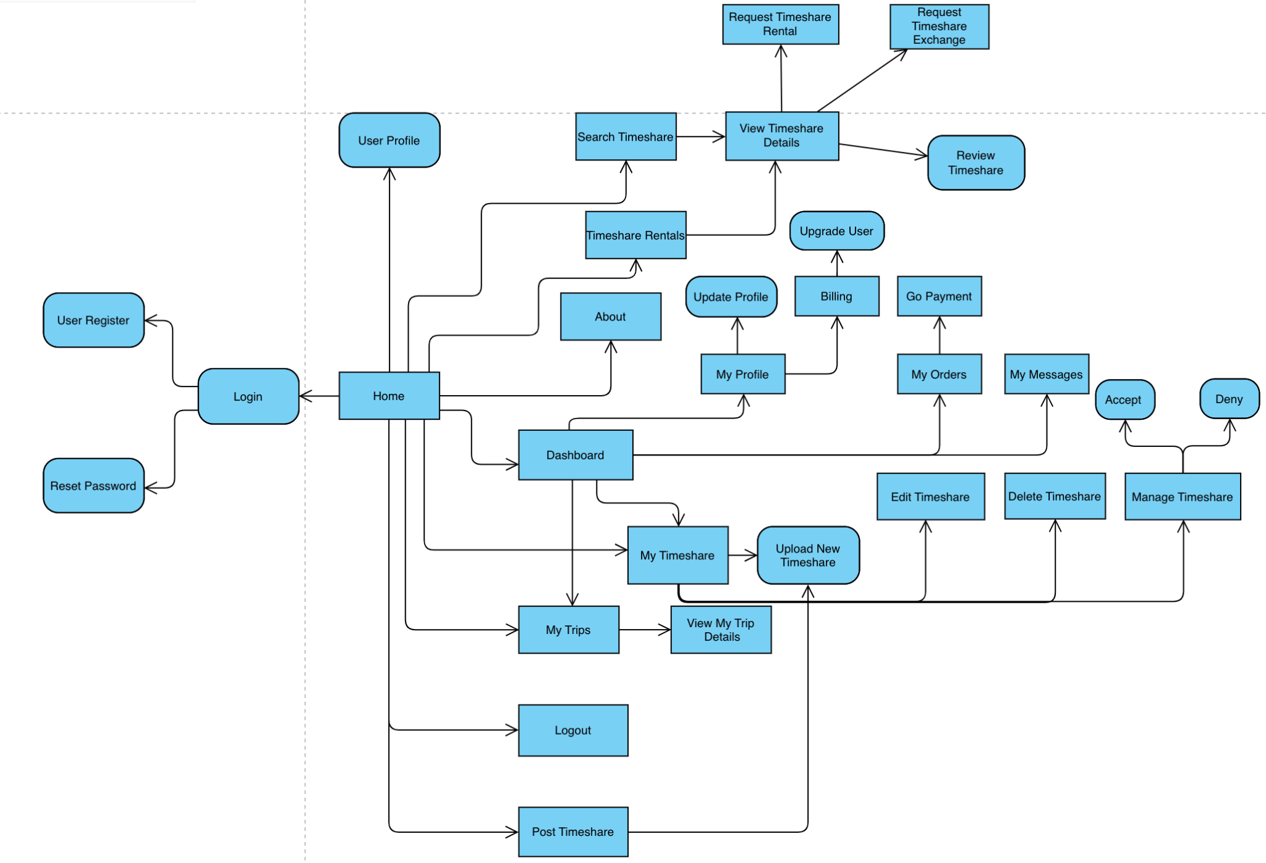

#### ***b. Screen Details***

*[Provide the descriptions for the screens in the Screens Flow above]*

| **#** | **Feature** | **Screen** | **Description** |
| --- | --- | --- | --- |
| 1 | View timeshare list | Home, Timeshare Search list | Main landing page of the system |
| 2 | Login | Login | Provides login form for authentication |
| 3 | Register | Register | Provides register form for account creation |
| 4 | Reset password | Reset password | Provides a form to change password |
| 5 | Search timeshare | Home, Timeshare Search list | Provides search form for searching timeshare based on resort name and timeshare date |
| 6 | View Timeshare detail | Timeshare Details | Displays detailed informations of the timeshare along with resort reviews |
| 7 | Request timeshare rental | Timeshare Rental Booking | Provides a form to input renter’s information |
| 8 | Request timeshare exchange | Timeshare Exchange Booking | Provides a form to choose exchanger’s timeshare and input basic information |
| 9 | View profile | User Profile | Display user information |
| 10 | Edit profile | User Profile | Provides a form to edit user information |
| 11 | Change password | User Profile | Provides a form to change password |
| 12 | Request email verify | User Profile |  |
| 13 | Verify Email | Verify Result | Display email verification status (Success or failed) |
| 14 | View my timeshares | My timeshares | Display timeshare list of the current user |
| 15 | Edit my timeshares | Edit Timeshare | Display a form to edit current user’s timeshare |
| 16 | Delete my timeshares | My timeshares | Display a confirmation dialog when clicks on “Delete” button |
| 17 | Upload a timeshare | New timeshare | Display a form to fill informations of the timeshare |
| 18 | Accept a timeshare requests | Timeshare request list |  |
| 19 | Deny a timeshare request | Timeshare request list |  |
| 20 | Pay a timeshare rental | My reservations, Payment | A screen to complete timeshare rental payments |
| 21 | Pay for membership | Payment | A screen to complete membership payments |
| 22 | Upload a resort | New resort | Displays a form to upload a resort |
| 23 | Edit resort | Edit resort | Displays a form to edit a resort |
| 24 | View statistics | Main admin dashboard | Display total users, total timeshares and a list of recent requests |

#### ***c. User Authorization***

*[Provide the system roles authorization to the system features (down to screens, and event to the screen activities if applicable) in the table form as below – replace Role1, Role2,… with the specific system user role names]*

| **Screen** | **Guest** | **User** | **Admin** |
| --- | --- | --- | --- |
| Main page | X | X | X |
| View timeshare list | X | X | X |
| Authentication | X |  |  |
| Sign up | X |  |  |
| Login | X |  |  |
| Request reset password | X |  |  |
| User dashboard |  | X |  |
| Update user info |  | X |  |
| Change password |  | X |  |
| Request verify email |  | X |  |
| Timeshare details | X | X | X |
| View timeshare details | X | X | X |
| Request timeshare rental |  | X |  |
| Request timeshare exchange |  | X |  |
| Upload resort review |  | X |  |
| View resort reviews | X | X | X |
| Manage timeshare |  |  |  |
| View my timeshares |  | X |  |
| Accept timeshare requests |  | X |  |
| Deny timeshare requests |  | X |  |
| Admin dashboard |  |  |  |
| View statstics |  |  | X |
| User management |  |  | X |
| View user list |  |  | X |
| Edit user |  |  | X |
| Ban user |  |  | X |
| Unban user |  |  | X |
| Resort management |  |  | X |
| View resort list |  |  | X |
| Add resort |  |  | X |
| Delete resort |  |  | X |
| Edit resort |  |  | X |
| Add units |  |  | X |
| Edit units |  |  | X |
| Delete a unit |  |  | X |
| View review list |  |  | X |
| Delete a review |  |  | X |
| Timeshare management |  |  | X |
| View timeshare list |  |  | X |
| Edit timeshare |  |  | X |
| Delete timeshare |  |  | X |
| Payment management |  |  | X |
| View payment list |  |  | X |
|  |  |  |  |

In which:

· Guest: User that has not been registered on the system

· Member: User that registered on the system

· Admin: People who administrate the system

## 4. Entity Relationship Diagram

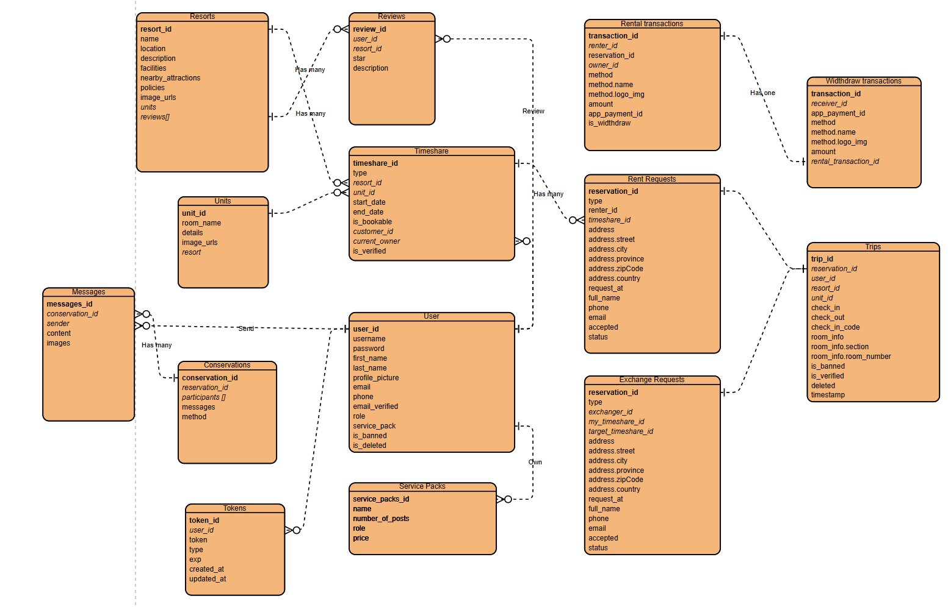

## 5. Sequence diagram

### **Register**

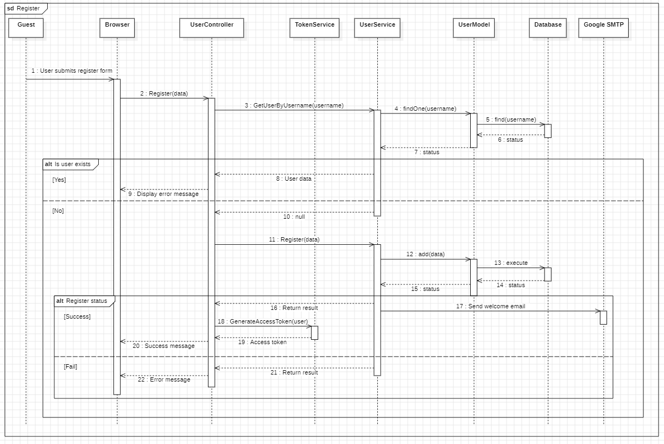

### **Post a timeshare**

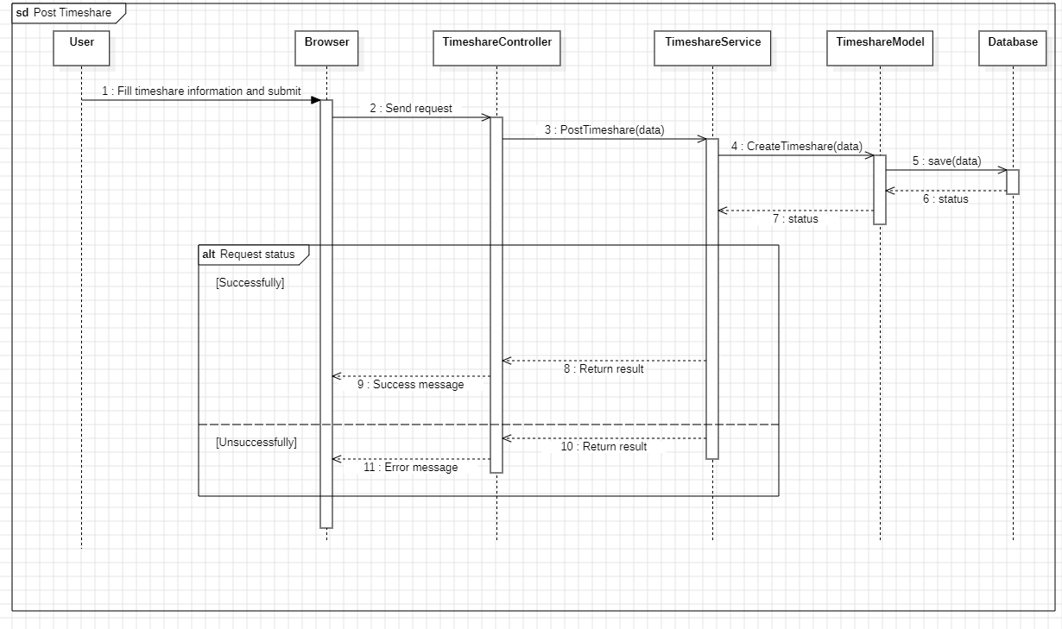

### **Request a timeshare rental**

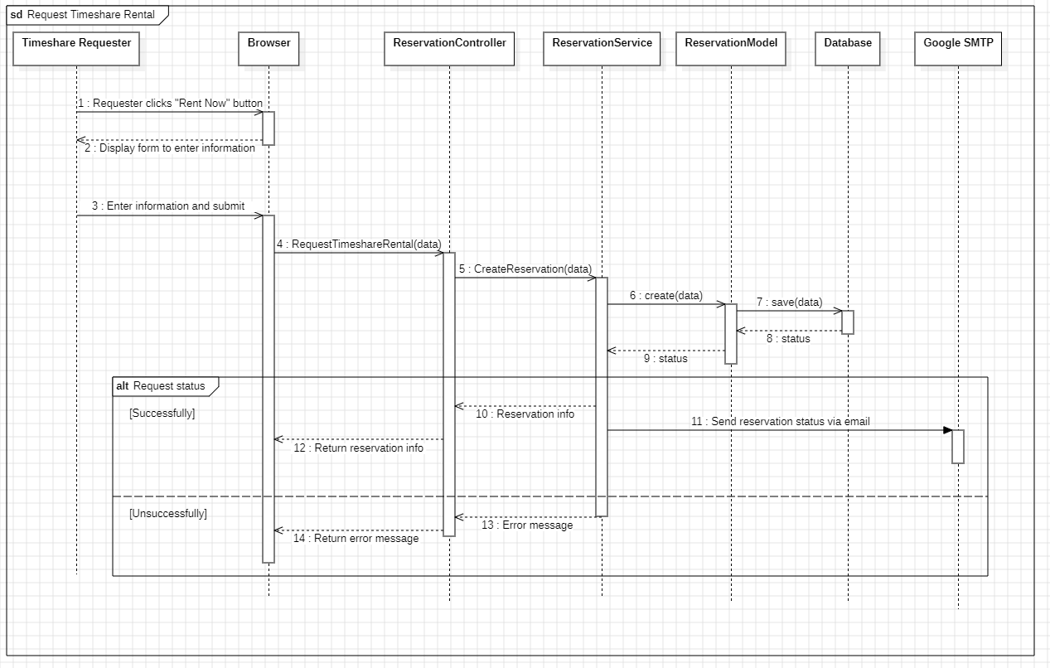

### **Accept a timeshare rental**

